EDEN WIMPY DOUBLES DEVELOPMENT PROJECT
31 JANUARY 2023

The EDEN WIMPY DOUBLES PROJECT is one of the annual development components of EDEN Biathlon. It is organised by the Development Component of EDEN Biathlon in cooperation with DCAS and WIMPY [local sponsor]. The main objective is to develop the sport code and is aimed at the younger and older athletes and to develop the younger athletes also as timekeepers.

The mechanics of the project is as follows: an established biathlete must bring a partner who has never partake in biathlon to do one of the components of biathlon [running or swimming]. There is no restriction on gender, age, race…….we in many cases get the situation that the athlete pair up with one of his/her parents or even grandparents! Each one compete in his/her age group and points are allocated on a point scale – the team with the most points is declared the winner! In many cases the new participant get hooked and we have won many such athletes for the sport!

While their companions compete the team member are taught the basics of timekeeping and introduced into it.

STATISTICS
Date: 31 Jan 2023
Time: 17:00 – 19:00
Venue: De Jager sport Complex Athletics Track, Oudtshoorn
NA Smit Swimming Pool, Oudtshoorn
Team: 57

MEDIA
WIMPY DOUBLES GOEIE AFSKOP ..... Die eerste tweekampbyeenkoms in 'n jaar het Dinsdag 31 Januarie op Oudtshoorn plaasgevind. A massive 47 teams competed in comparison with the 32 teams of last year. Die uitslae was:
Wenners:
1. Estie Bezuidenhout & Petra-Mari Fourie 2155
2. Markus Viljoen & Ninke Griffioen 2125
3. Pieter Schoeman & Johan Windt 2115

Aantal Spanne: 47

Wimpy het die pryse geborg.

PHOTO GALLERY
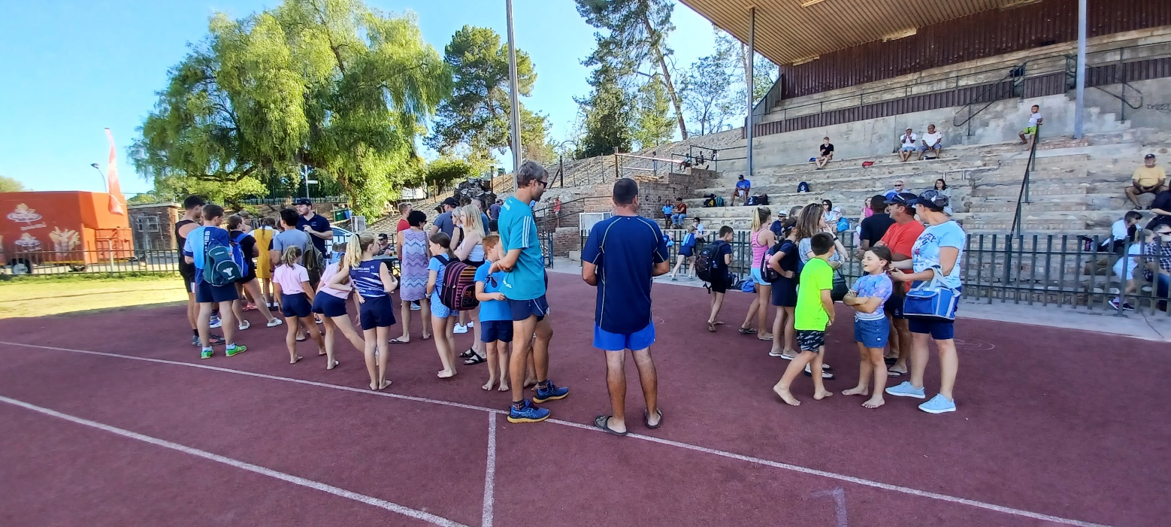

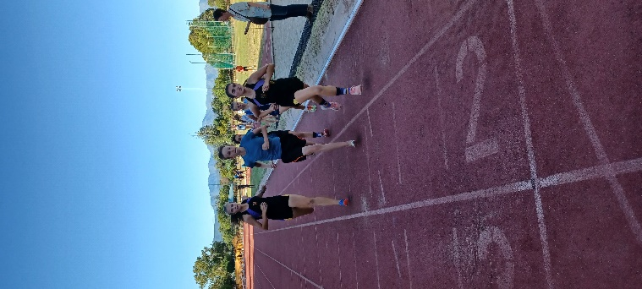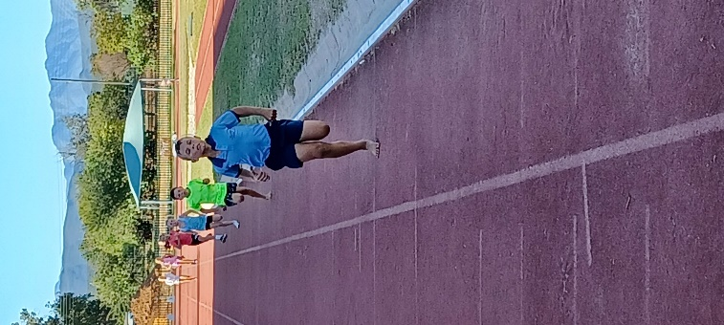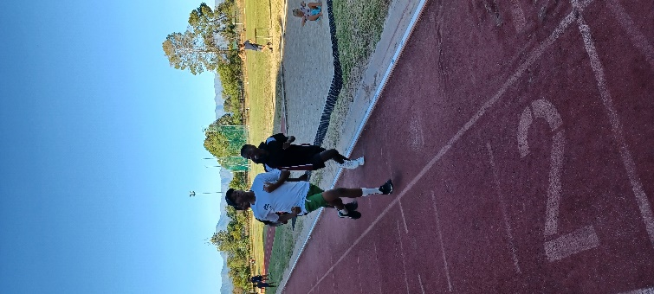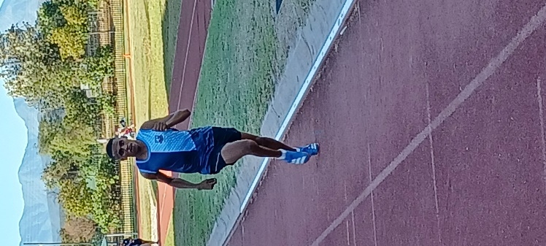

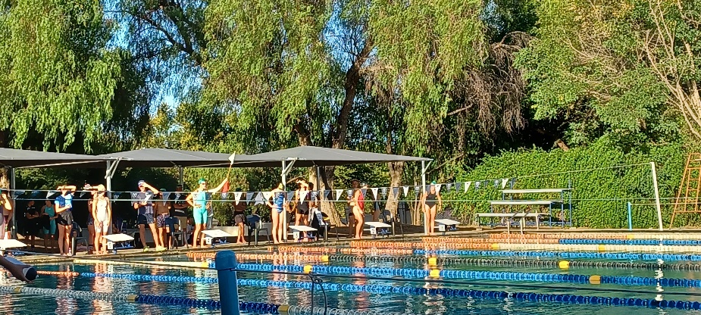
RESULTS [and attendance]
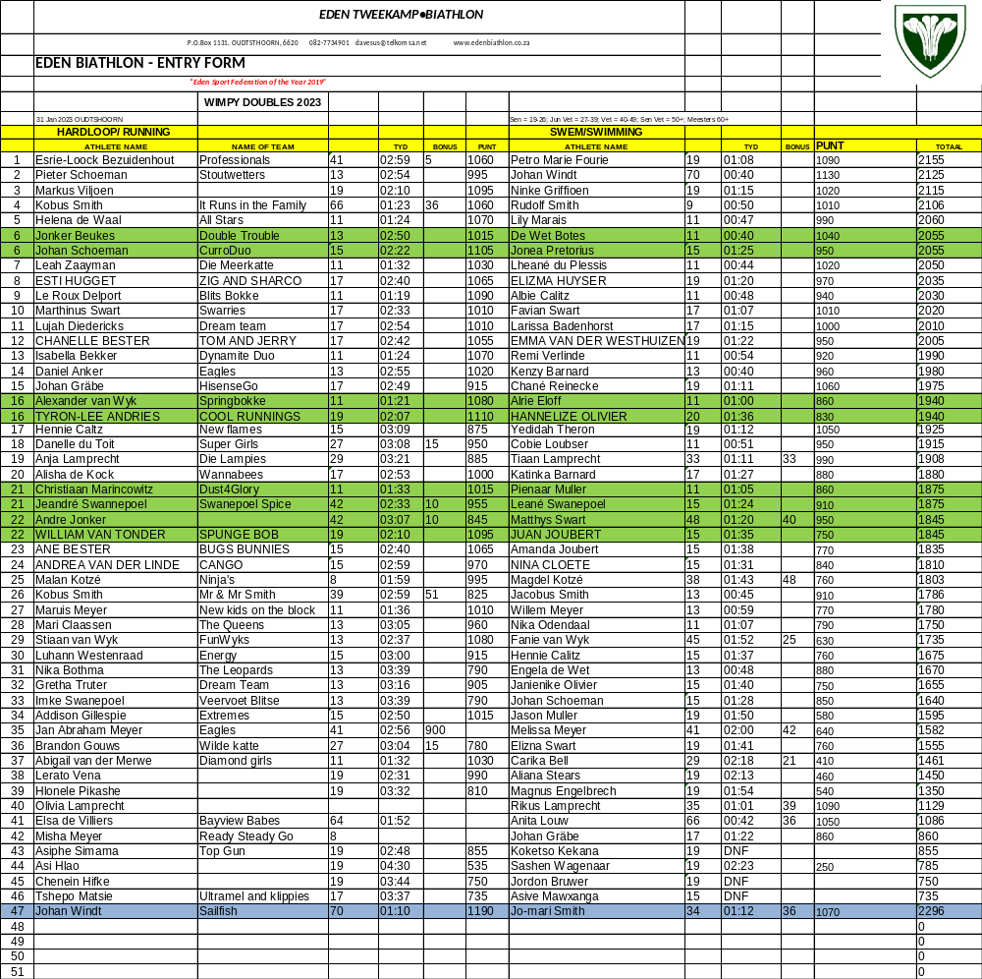

EDEN Biathlon would like to thank all role players that contribute to our Development programme, DCAS, the coaches, organisers and sponsors, for making the progress in biathlon possible.

Many thanks


Dave van der Walt
Operasionele Bestuurder
Operational Manager
082-7734901
EDEN TWEEKAMP•BIATHLON

Play Safe

