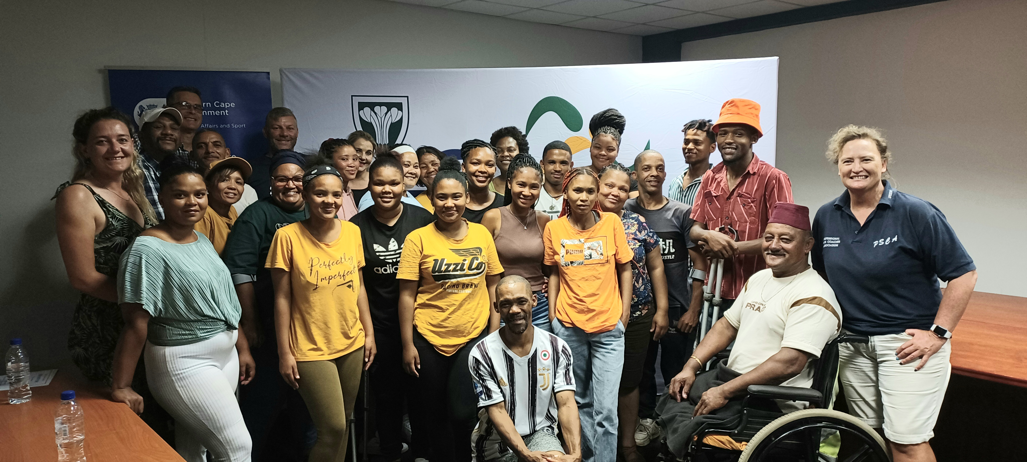
REPORT
2023 CAPACITY BUILDING WORKSHOP EDEN BIATHLON
2023..11.16
REPORT
KAPASITEITSBOU WERKSWINKEL
15 November 2023
OUDTSHOORN
18:00 – 20:30

KAPASITEITSBOU WERKSWINKEL GROOT SUKSES!
As deel van Eden Tweekamp se sosiale ontwikkelings program, bied hulle jaarliks in samewerking met die Weskaapse Departement van Kultuursake en Sport (DCAS) hierdiè kursus aan. Daar word gekonsentreer op dames en gestremde persone en is prakties en basies van aard. Op 15 Nov 2023 het 36 persone hierdiè kursus in die Eden Sport Akademie op Oudtshoorn bygewoon. Adri Odendaal (Cansa) het die groep ingelig ook borskanker terwyl Delia van Biljon (swem) en Dave van der Walt (baan) tydhou kursus aangebied het. Jean Neethling (DCAS) en Stephnie McKay (Eden Tweekamp voorsitter) het die sertifikate uitgedeel. Groot dankbaarheid is uitgespreek deur die deelnemers.

- Die ontydige ESKOM beurtkrag.
- Vervoer van persone na venue.
- Geweldige hitte – was daardie dag 43º op Oudtshoorn

Die organiseerders is egter tevrede met die opkoms en het heelwat positiewe terugvoering gekry. Daar was baie goeie wisselwerking tussen die aanbieders en deelnemers.

BESONDERHEDE:
- Datum: Woensdag 15 November 2023
- Tyd: 18:00 – 20:30
- Venue: Eden Sport Academy, Oudtshoorn
- Organiseerder: Dave van der Walt 082-7734 901]
- Verversings: Alma Botes Caterers.



INVITATION
CAPACITY BUILDING WORKSHOP – OUDTSHOORN
15 NOVEMBER 2023
18:00 – 20:00
EDEN SPORT ACADEMY

The EDEN BIATHLON FEDERATION supported by the WC Department of Cultural Affairs & Sport plans to host a capacity building workshop in Oudtshoorn concentrating mainly on women and special need persons. The main objective of this workshop is to prepare interested persons in TIMEKEEPING in biathlon, athletics, swimming and other relevant sporting codes. This will be practical orientated – no tests will be written! Certificates will be issued at the end of the workshop. This will be free of charge. Only a limited number of 30 persons can be accommodated. It will be conducted at EDEN Sport Academy [De Jager Sport Complex] on Wednesday 15 November 2023 from 18:00 – 20:00.

A brief slot will also be allocated to CANSA to inform the clinic-goers more about breast cancer.

Anybody interested is welcome to attend. We specifically would like to invite our women and disabled to make use of this opportunity.

All interested person can forward their names to Dave van der Walt – davesusvdw@gmail.com at the latest on Monday 13 November 2023. For more information you can contact him at 082-7734901 or Stephnie McKay at 082-0988439.

Hope to see you there!


Dave van der Walt
Honorary Member
082-7734901
EDEN TWEEKAMP•BIATHLON

Play Safe
ENTRY FORM
NAME & SURNAME CELL NO EMAIL ADDRESS
___________________ ________________ _________________________
___________________ ________________ _________________________
___________________ ________________ _________________________
___________________ ________________ _________________________
___________________ ________________ _________________________
___________________ ________________ _________________________
___________________ ________________ _________________________
PS. If not enough space, duplicate entry form please

PROGRAMME

CAPACITY BUILDING WORKSHOP KAPASITEITSBOUWERKSWINKEL
PROGRAMME
TIMEKEEPING / BREAST CANCER
18:00
15 November 2023
EDEN SPORT ACADEMY / EDEN SPORTAKADEMIE
OUDTSHOORN
PROGRAM
1 WELKOM/WELCOME Stephnie McKay [Chairperson EDEN Biathlon]
2 OPENING Jean Neethling [DCAS]
3 BREAST CANCER INFO Adri Odendaal [CANSA]
4 TYDHOU – SWEM Delia van Biljon
5 TIMEKEEPING – TRACK Dave van der Walt
6 BEDANKINGS Stephnie McKay
7 CERTIFICATE CEREMONY Dave van der Walt
LIGTE VERVERSINGS

CHECKLIST CAPACITY BUILDING WORKSHOP 15 NOV 2023

- Invite letter draft
- Topics - Timekkeepings & breast cancer
- Invites out
- Finalise venue Eden Sport Academy
- Invite guest presenters: Adri Cansa, Delia swim timekeeping, Dave track timekeeping
- DCAS banners
- Jean – opening address
- Corne Botha – stop watches
- Eden Biathlon banners - Corne
- NA Smit – starter
- Kateder
- Sertifikate – DCAS
- Papier – sertifikate
- Pen & Papier – deelnemers
- Lêers vir deelnemers – OTB?
- Water
- Verversings – kerrie & rys?
- Koeldranke – klein cokies
- Servette
- Media projector
- Generator – standby
- Petrol - generator
- Presensielys
- Laptop
- Leads
- Programme
- Transport
- Guidelines copy

CERIFICATE

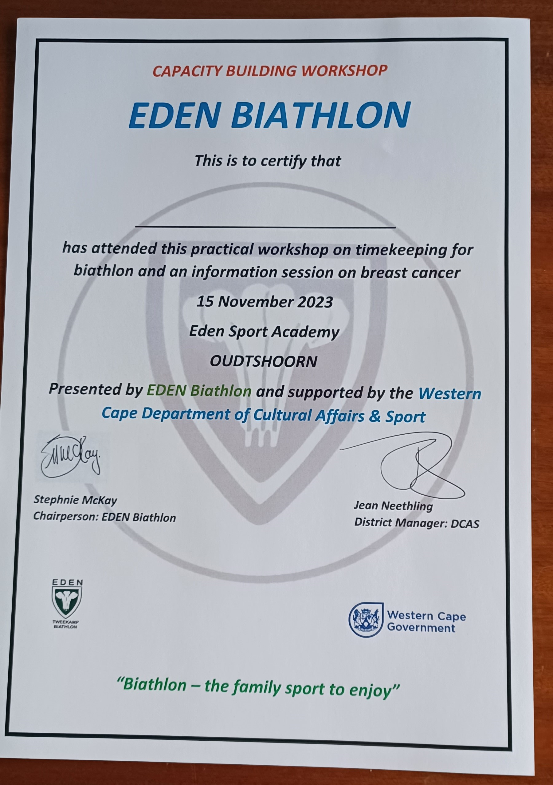

ATTENDANCE & COVID CONTROL REGISTER

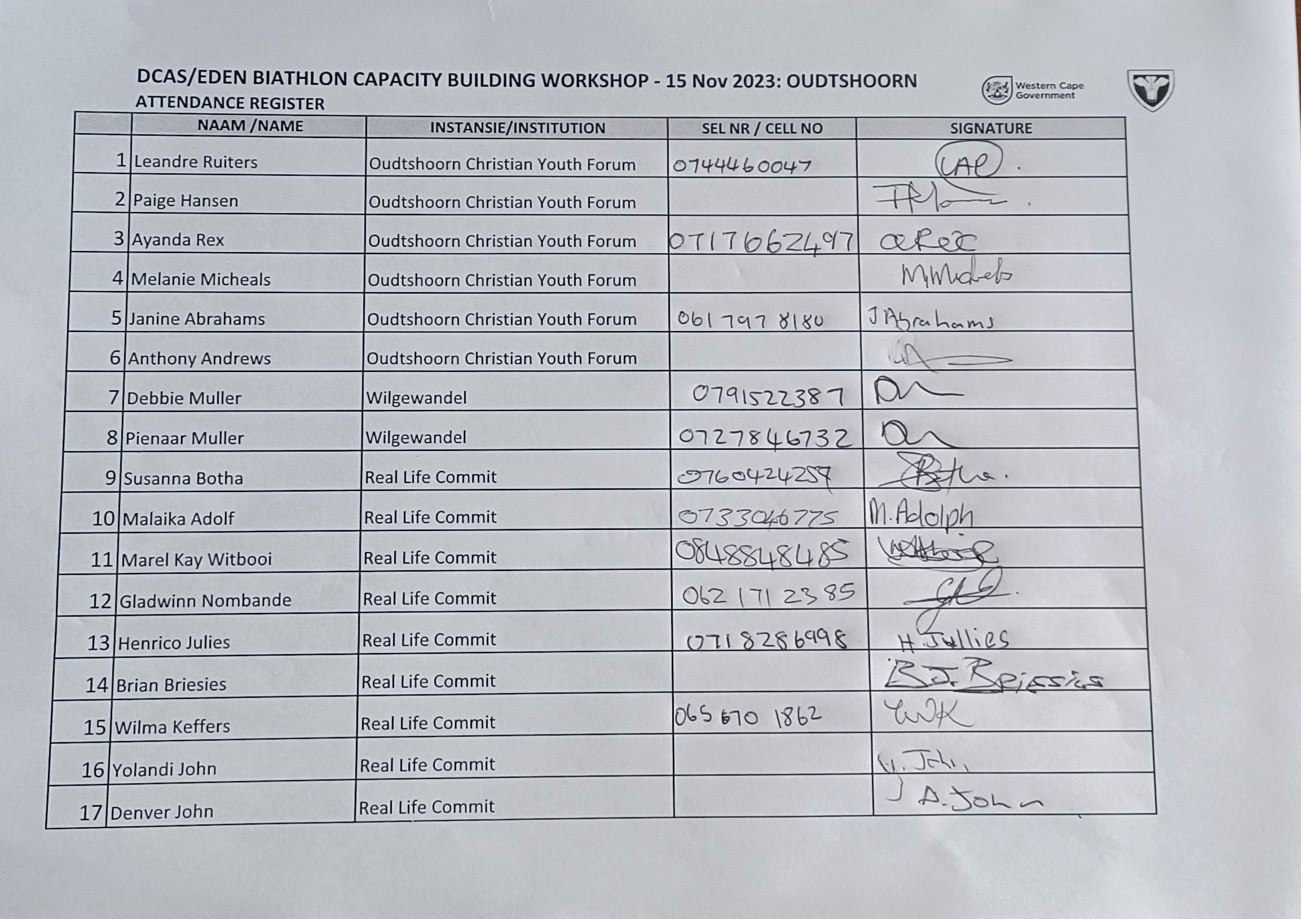

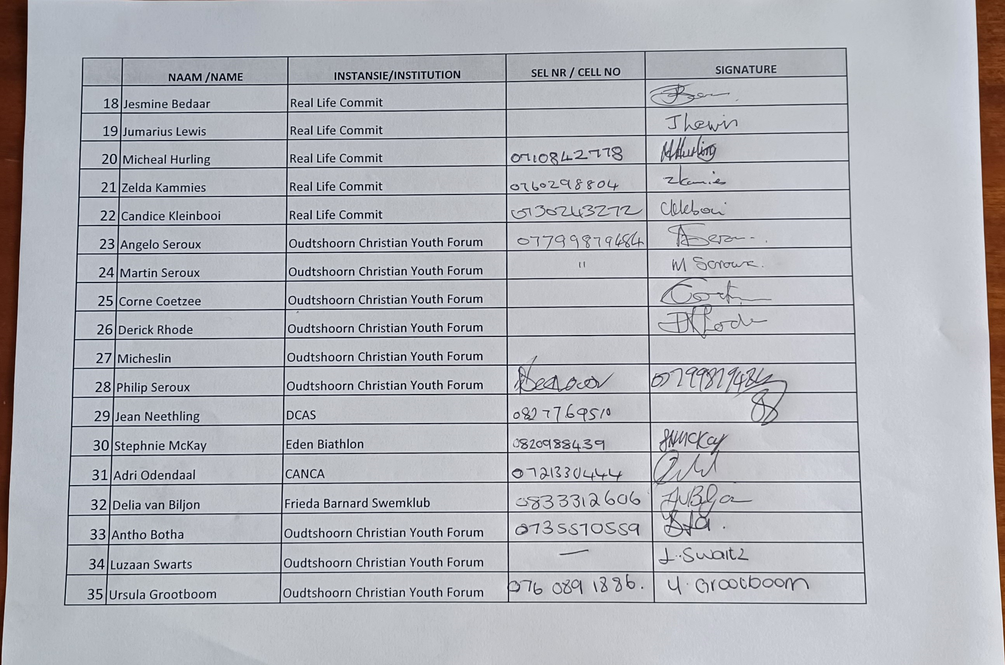

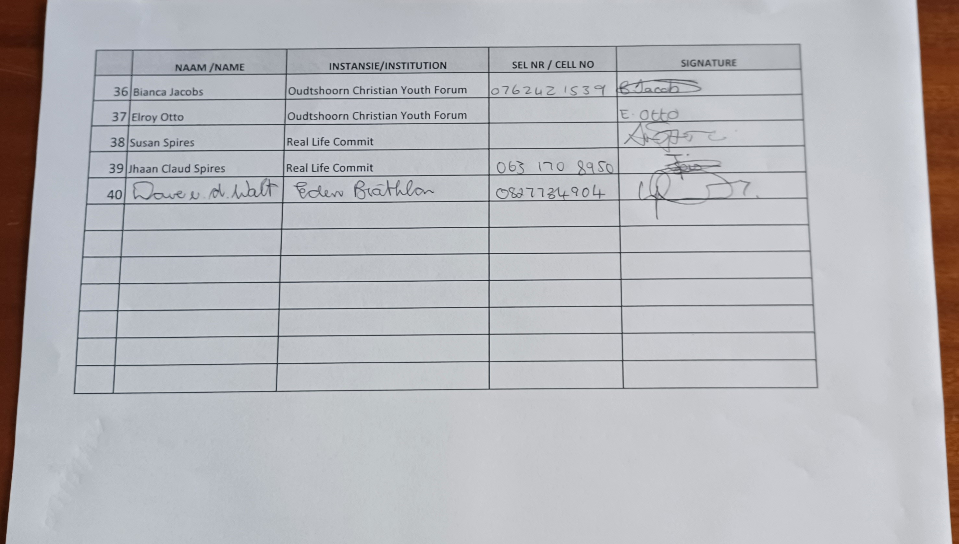

GALLERY

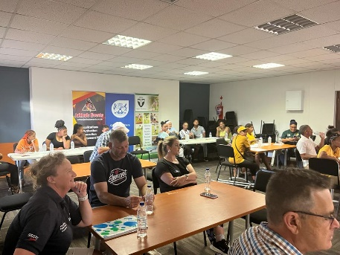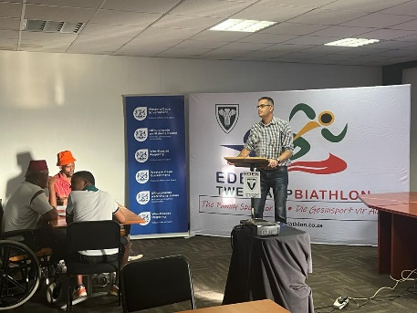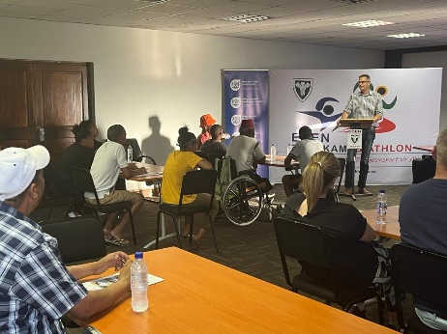

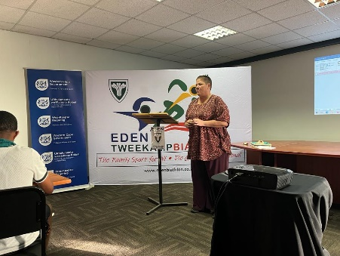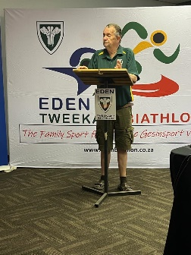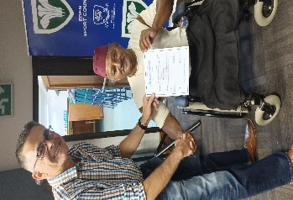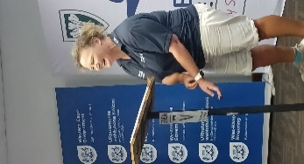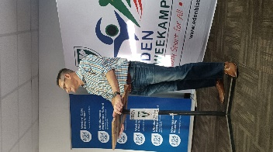

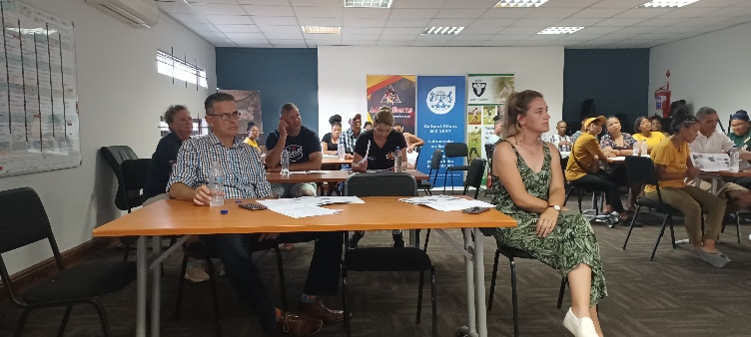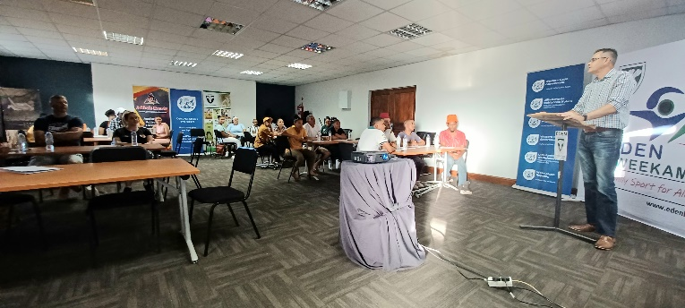

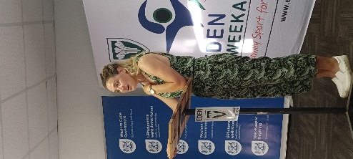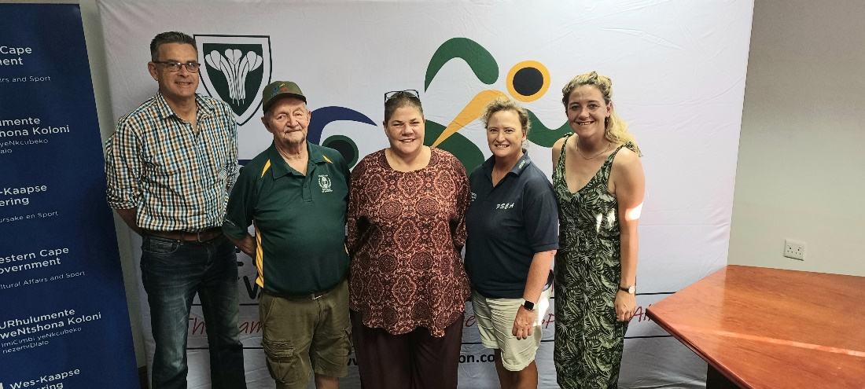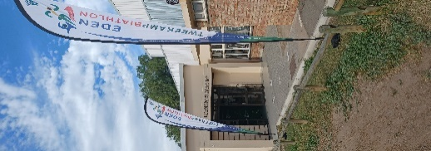

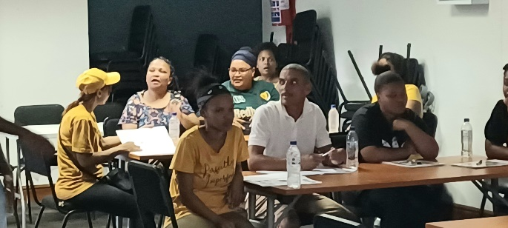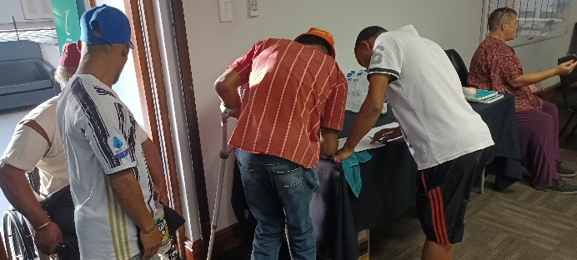

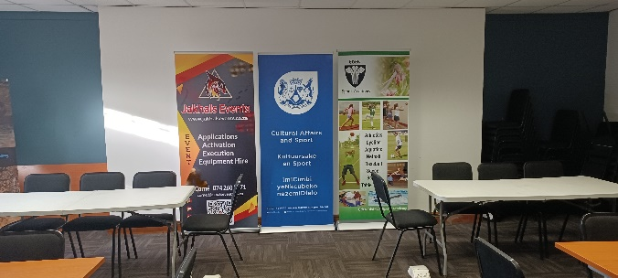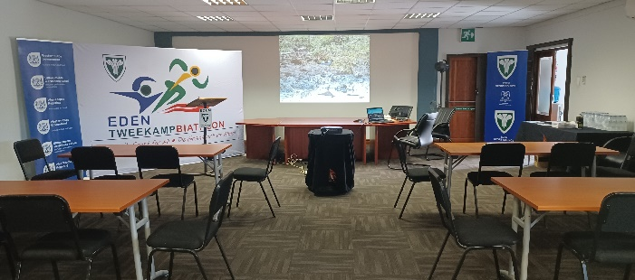

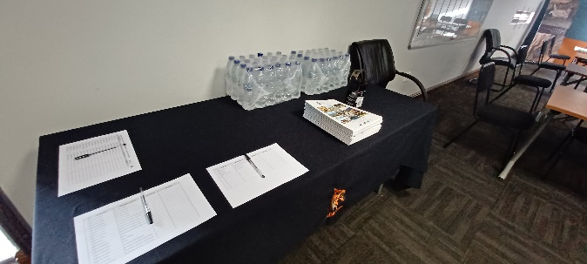

The EDEN Biathlon Federation would like to thank all the role players, specifically DCAS, for their support in the development of the sport code in the Eden sport district.

Many thanks

Dave van der Walt
Operasionele Bestuurder
Operational Manager
082-7734901
EDEN TWEEKAMP•BIATHLON

Play Safe

