CAPACITY WORKSHOP KAPASITEITSWERKSWINKEL
12 MARCH/MAART 2019
EDEN SPORT ACADEMY, DE JAGER SPORTKOMPLEKS
18:00 – 20:30

“We as women can do it!”
“Ons as dames kan dit doen!”


REPORT

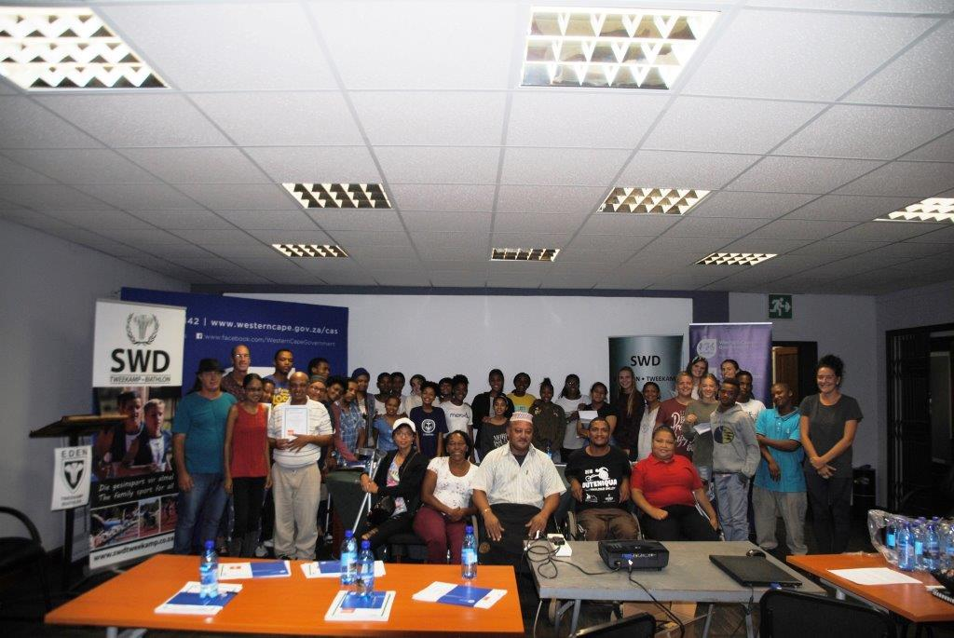
BACKGROUND

EDEN BIATHLON HOST CAPACITY BUILDING WORKSHOP FOR WOMEN AND DISABLED

Almost 50 women, girls & persons with special needs attended this workshop on Tuesday 12 March in Oudtshoorn. It was hosted in partnership with the WC Department of Cultural Affairs & Sport. The theme was "We as Women & Disabled can do it!" Basic timekeeping in track and swimming were presented by Abrie de Swardt and Thinus Eloff respectively while Shireen Noble (ASWD President) addressed the workshop on Women & Disabled in sport administration. Jessica Gerber (Protea cyclist) delivered a strong motivation to all to never give up in reaching for the top. Jean Neethling (DCAS) congratulated Eden Biathlon on their initiative to host workshops like this - this make Eden Biathlon leaders in their own right. Corne Bence (EDENSC) presented the certificates. In her welcome address Stephnie McKay (Chairperson Eden Biathlon) thanked DCAS for their support in hosting such events. This workshop was organised by Dave van der Walt (Operational Manager of Eden Biathlon) in line with the vision of Eden Biathlon to build capacity in the field of women en disabled.

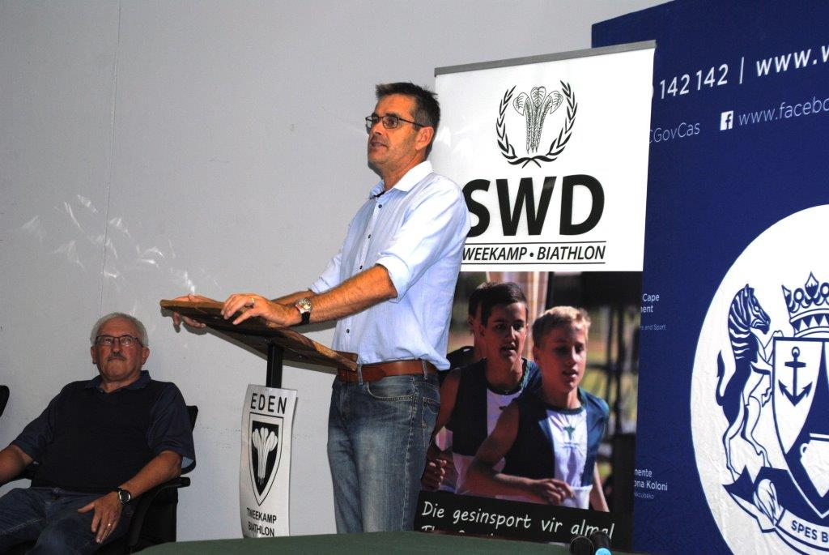

Jean Neethling, DCAS [Eden] opening the CBWS

PROGRAMME
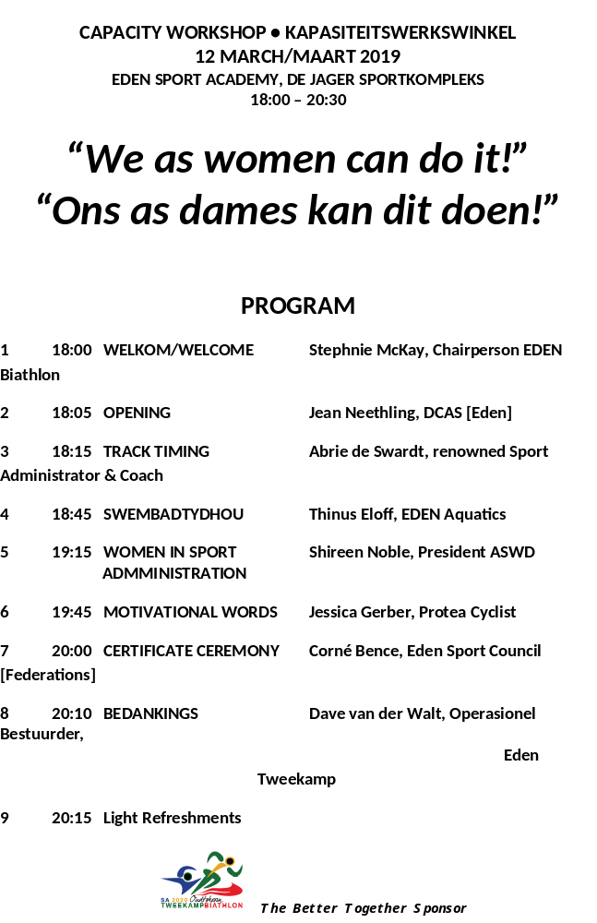

INVITATION LETTER


ATTENDANCE REGISTER
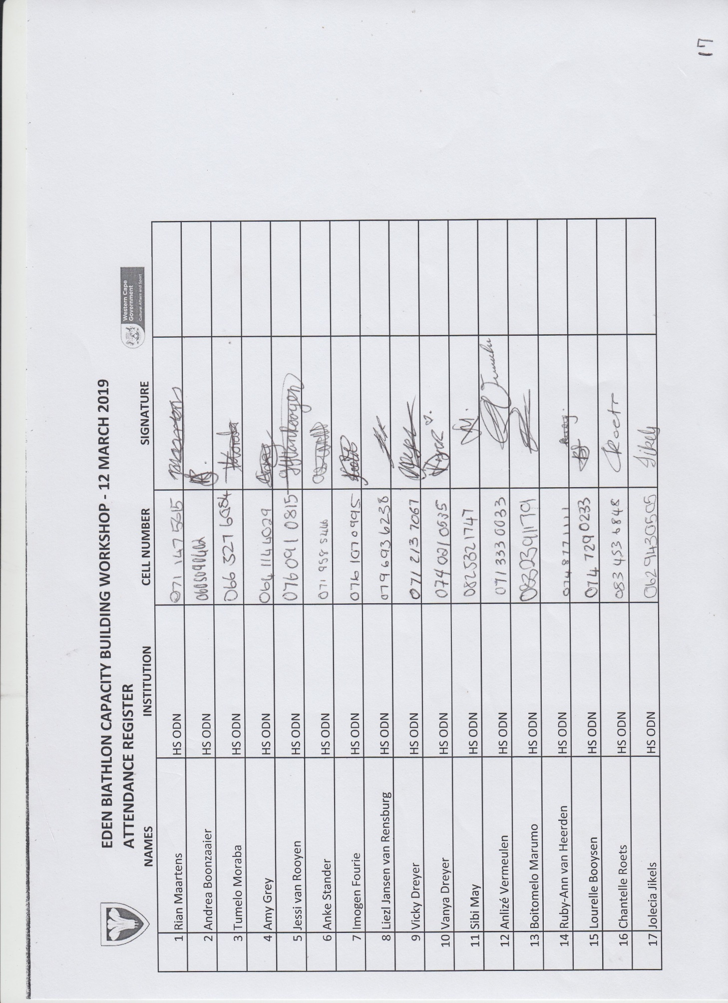

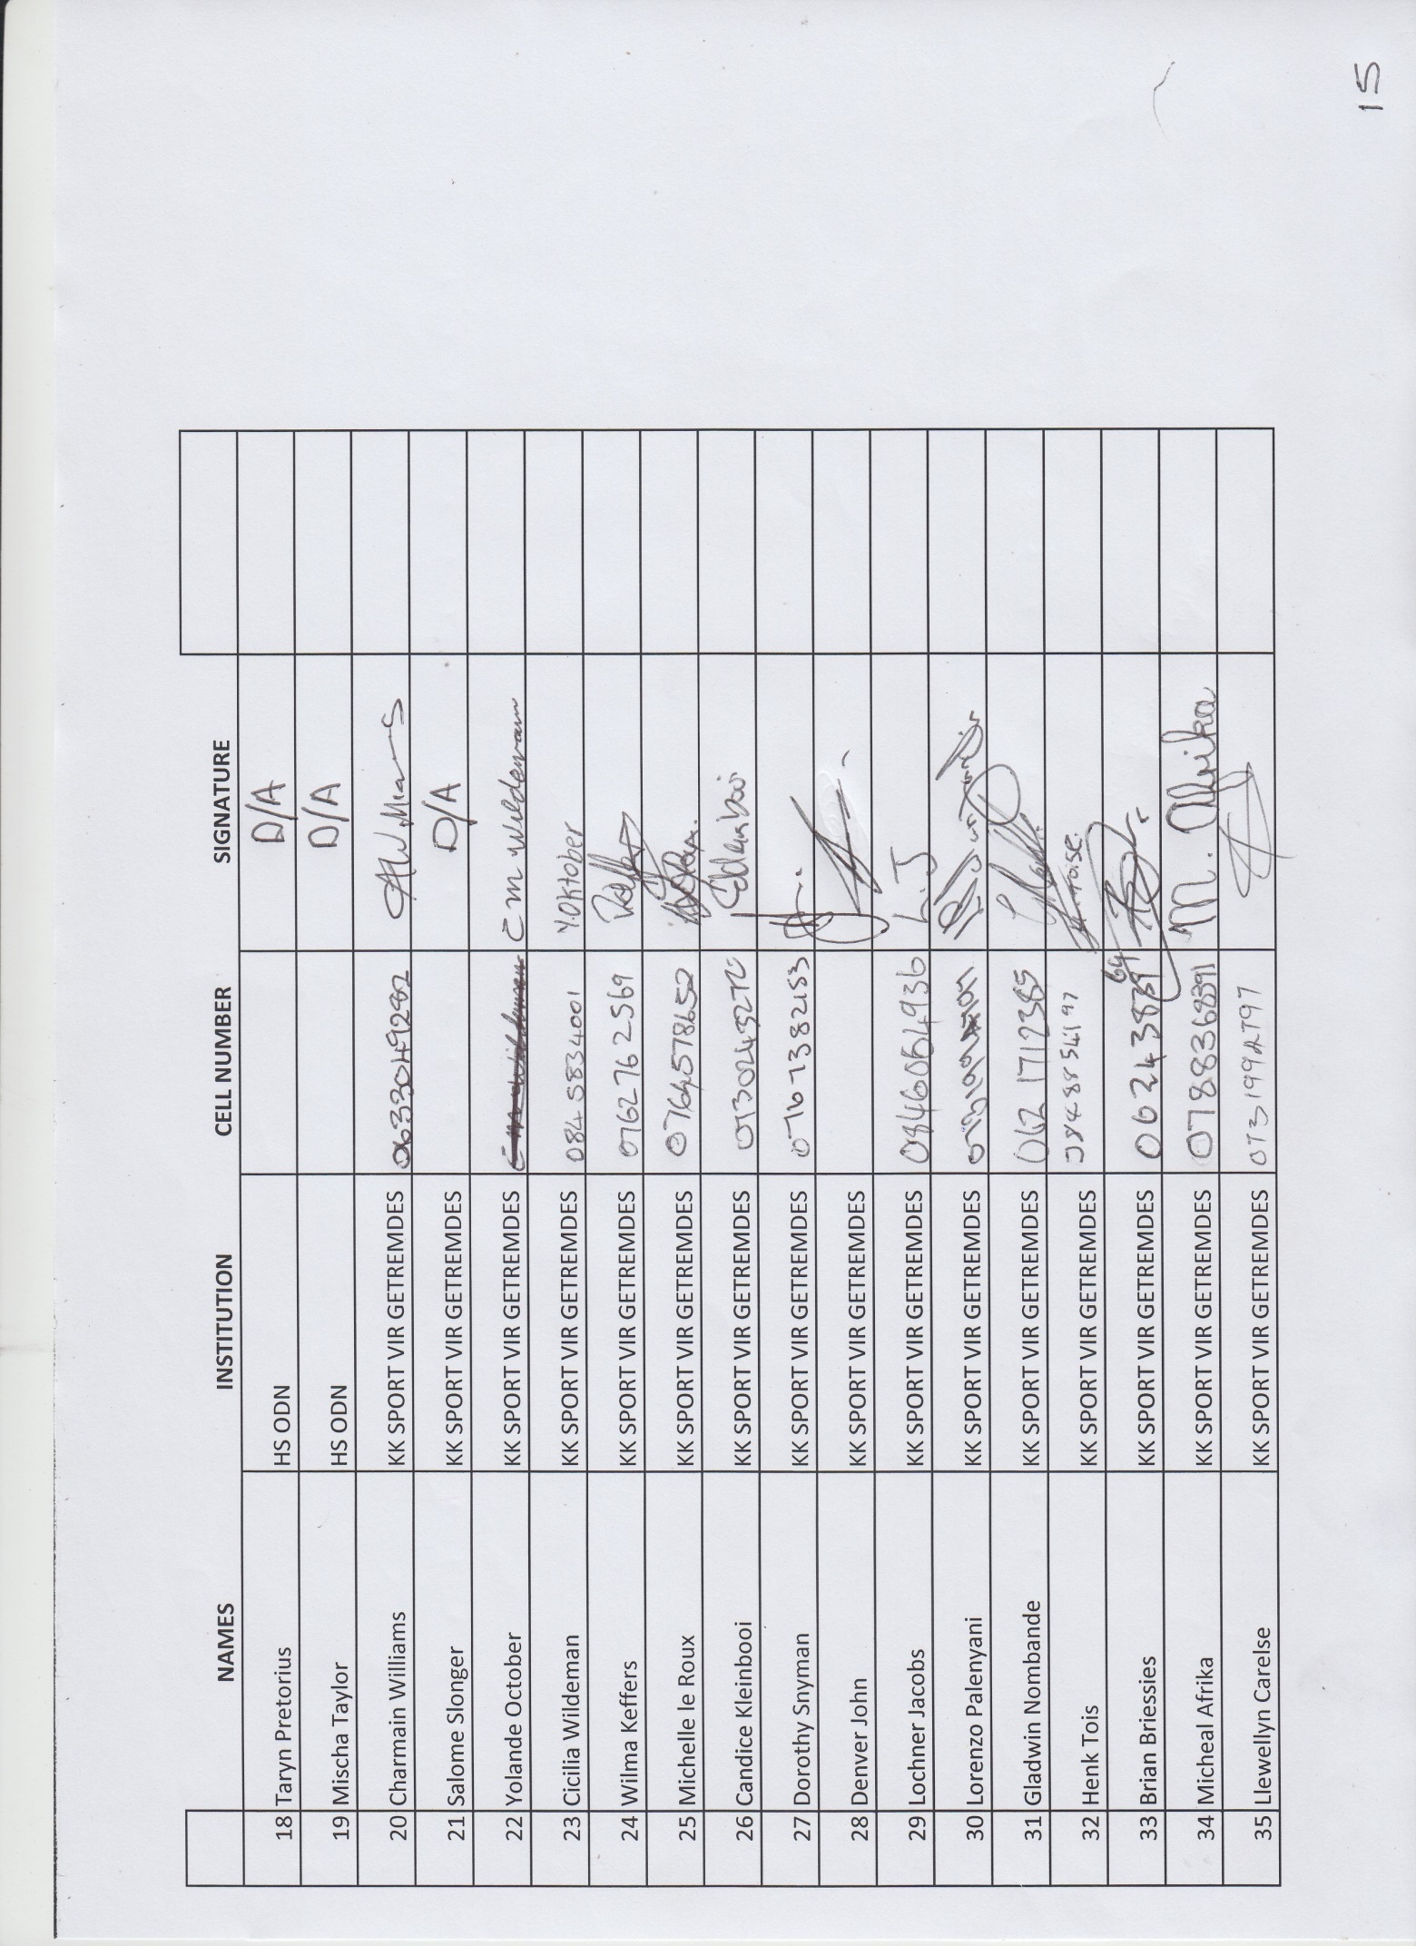
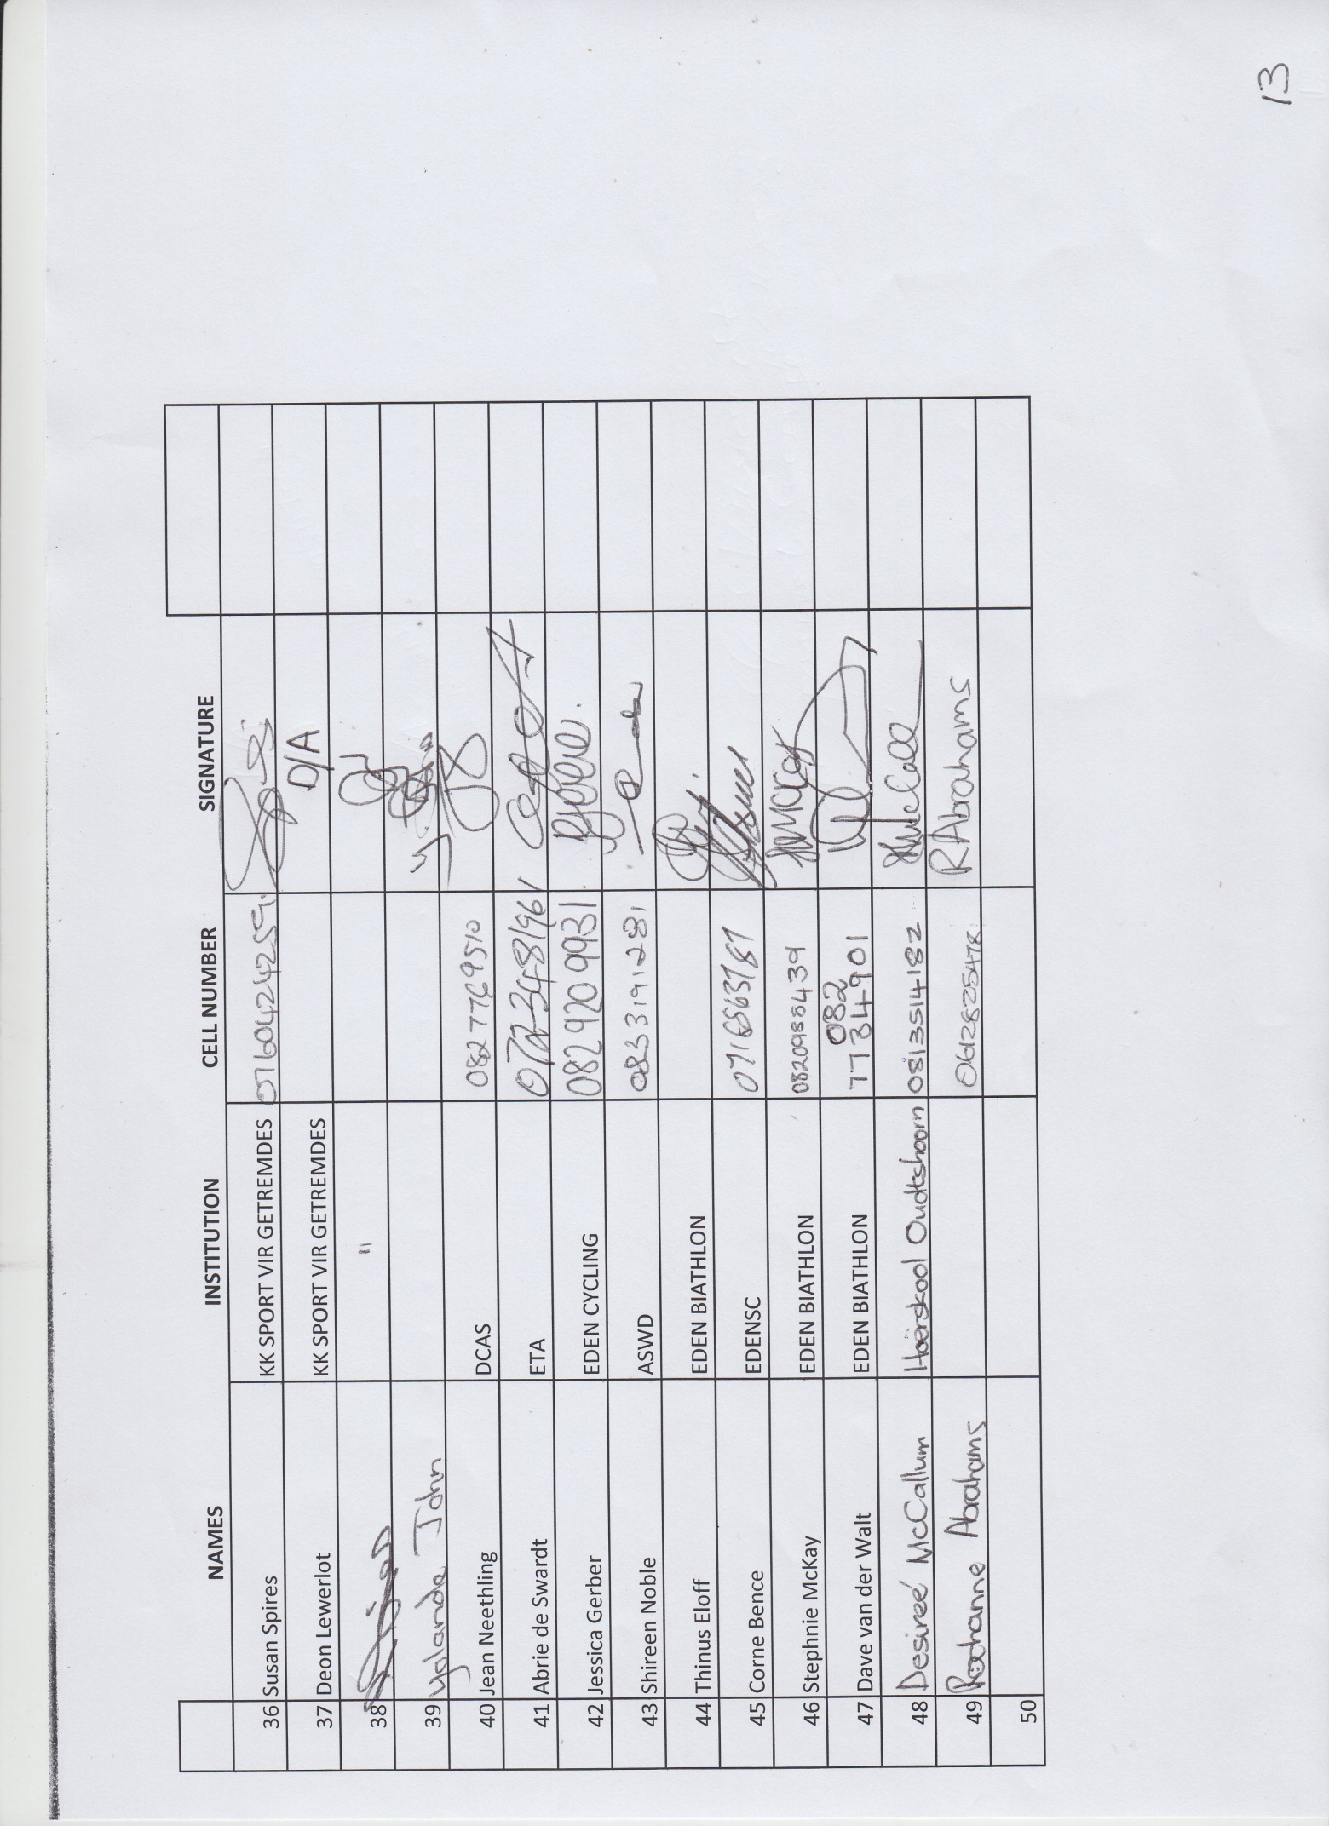
CERTIFICATE


MANUAL
TIMEKEEPING

Technical officials are required to control all swimming competitions.
Application to become a Timekeeper will be accepted from persons 16 years and over.
There will be a register of qualified Officials.

1.1 ROLE
Timing is the swimmer’s measure of performance. The role of timekeepers is to accurately determine the time it took each swimmer to cover the distance of the event.
Final placement of the swimmers in each event is determined by their times and finish order. Therefore, precision and accuracy are important for timekeepers.

1.2 REPORTING FOR GALA DUTY
All Technical Officials should, when attending at any competitive swimming event held in South Africa, wear the poolside uniform for men or women as set out below.
- White shirt
- Navy Blue trousers or shorts (shorts can be worn for heats and normal galas, long trousers
only for finals)
- White closed shoes

You should ensure you report to the CHIEF TIMEKEEPER or other nominated official, at least 45 minutes prior to the start of the gala (unless you have been informed otherwise).

1.3 DUTIES AND EQUIPMENT
The Chief Timekeeper will allocate your assigned lane for which you are responsible.
FINA require three timekeepers allocated to each lane. At some events however, this may not always be possible and therefore, there may be fewer than three on each lane.
The Chief Timekeeper may issue you with a watch. On receiving the watch check you know how the following functions operate:

- start
- Stop
- Returned to zero (resets)
- Split time feature (if appropriate) is working
The first joint of the dominant forefinger should be used to start a manual stop watch NOT the thumb or any other finger.
If a back-up button is also being used, this should be stopped using the thumb of the dominant hand. The stop watch should then be stopped using the forefinger of the other hand.
The Chief Timekeeper should provide you with a lane sheet for each event and appoint one of the Timekeepers in each lane to carry out the following specific duties:
- The times recorded by each timekeeper in the lane should be entered onto the lane sheet
- Ensure that each lane sheet is signed by the nominated timekeeper (scribe) before it is submitted at
the end of the event

1.4 PROCEDURE FOR RECORDING A TIME
Prior to the start of a race the Timekeepers allocated to each lane should ensure that the race and swimmers’ details are correct before the race commences, these details include:
- Event Number
- Swimmer in correct lane Heat Number
- Swimmer in correct event Lane Number
- Swimmer in correct heat and lane Swimmer’s Name
- Swimmer’s name correct?
- Style of Stroke - Stroke correct?
- Distance to be swum - Number of lengths correct?
- Know the staring method being used, e.g. strobe light or whistle

Prior to each start, the referee will signal to the swimmers by a short series of whistles, inviting them to remove all clothing except for swimwear, followed by a long whistle, indicating that they should take their positions on the starting platform, or for backstroke swimming and medley relays to immediately enter the water.
For the backstroke and medley relay events the referee will sound a second long whistle requesting the swimmers to return to the starting position.

On hearing the long whistle timekeepers:
- May stand up or remain seated but MUST ensure that they have a clear view of the starting signal
(strobe) – if this view is obstructed by swimmers or other officials then it is the timekeeper’s
responsibility to adjust their own position to ensure an unrestricted view.
- Must listen/watch intently for the starting signal
When the starting signal is given timekeepers must:
- start the watch
- sit down
- check that the watch is running

If the watch fails to start or stops during a race a Timekeeper must inform the CHIEF TIMEKEEPER immediately in order that a reserve timekeeper/watch can be called in.
When the swimmer is 15m from the end during the last length of the race the Timekeeper prepares to take the swimmer's time by
- standing up to indicate readiness to the Chief Timekeeper
- pick up the back-up button (if used)
- standing immediately above the allocated lane
- looking DIRECTLY DOWN at the wall where the swimmer will touch to finish the race
- DO NOT stand on the top of the electronic timing pad!

When the swimmer is seen to touch the finish wall, the timekeeper stops the watch and presses the back-up button (if used). (Do not try to anticipate the swimmer finishing, make sure you actually see the swimmer touch the wall then immediately press the stop button).
Immediately the watch has been stopped the Timekeeper will return to his/her seat, sit down and read out the time recorded on the watch to the one timekeeper appointed for scribe duty. This Timekeeper records the times given by each timekeeper in the lane by noting them in the spaces provided on the lane sheet.
Each timecard has a space to write down the separate times for one, two or three Timekeepers in, Heats or Finals.

EVENT 2 LANE 3
HEATS FINAL
T/Keeper 1 ..... 01:22.30…… T/Keeper 2 ......01:22.32… T/Keeper 3 .....01:22.32……
OFFICIAL TIME ________________

Timekeepers must not compare/discuss times. The only time an individual timekeeper can declare is that recorded on their own watch. However if one time is significantly different, the Chief Timekeeper may wish to examine the time on the watch to be satisfied with the operation of the watch and/or efficiency of the timekeeper operating the watch.
Timekeepers should clear their watches when they their time has been recorded or when the referee signals the swimmers for the next race by a short series of whistles. (SW 2.9.3)
If you do not have a swimmer in your lane during a race, you must always write NO SWIMMER clearly across where the times would have been written had there been a swimmer. This is to ensure that you do not inadvertently write wrong times down for future races.

1.5 CALCULATING AN OFFICIAL MANUAL TIME
At most galas, official manual times are calculated by the Gala Admin staff when required.
However, it is important to know how times are calculated to ensure a full understanding of the timekeeping process and, should it be necessary to use a fully manual process, such as in the event of a total failure of the electronic timing equipment.
To determine the official time for the swimmer, observe the following guidelines.

WHEN THERE ARE THREE (3) TIMEKEEPERS ON A LANE:
If all three watches read the same time – that is the official time.
Timekeeper 1 01:18.38* Timekeeper 2 01:18.38* Timekeeper 3 01:18.38*
Official time 01:18.38 Three watches same time

If two watches are the same – that is the official time.
Timekeeper 1 01:14.62* Timekeeper 2 01:14.64 Timekeeper 3 01:14.62*
Official time 01:14.62 Two watches same time

If all three watches differ – take the middle time – that is the official time.
Timekeeper 1 01:14.89 Timekeeper 2 01:14.91 Timekeeper 3 01:14.90*
Official time 01:14.90 middle time of the three

WHEN THERE ARE THREE (2) TIMEKEEPERS ON A LANE:
If all three watches read the same time – that is the official time.
Timekeeper 1 01:09.01* Timekeeper 2 01:09.01*
Official time 01:09.01* Both watches agree

If two watches are the same – that is the official time.
Timekeeper 1 01:24.00 Timekeeper 2 01:23.96
Official time 01:24.98 Average time

If all three watches differ – take the middle time – that is the official time.
Timekeeper 1 02:46.53 Timekeeper 2 02:46.58
Official time 01:46.56 Average time

If the average time is to 5/1000 of a second, round up to the next 1/100th of a second.
Of course, when there is only one (1) Timekeeper on a lane, that one time will be the official time to be given on the lane sheet.
Sometimes mistakes do happen: in unusual circumstances therefore, one of the times recorded may be disregarded, e.g. it may be far too fast or, it could be far too slow in comparison with the other time(s) for the lane. Inform the Chief Timekeeper if your watch failed at the start or finish or if watch is wrong.

1.6 OTHER DUTIES
1.6.1 SPLITS - TAKING TIMES AT INTERMEDIATE DISTANCES
Timekeepers may be instructed by the Chief Timekeeper to record “splits” at intermediate distances in races longer than 100mtrs. Some watches do not have facilities for “splits’ and so this will normally be conducted by other officials using appropriate watches.
For completeness, the following information is provided for your information:
Pressing the “splits” button on your watch allows you to take the time of a swimmer at intermediate distances during a race, without stopping the full running time of the race.
Press the “splits” button when you actually see the swimmer touching the turning wall.
Record the time shown for the “split” on the lane sheet.

1.6.2 AUTOMATIC OFFICIATING EQUIPMENT (AOE)
Automatic Officiating Equipment (AOE) is a system of electronic timing used for swimming events. The system is linked to the starting system and to the timing pads hung into the water from the pool deck.
The system starts automatically when the start signal is given, and is stopped automatically when the swimmer hits the pads firmly on completion of the race.
The system by being automatic is much quicker to start and more accurate than hand held digital watches. When in use, the times recorded by this system always take precedence over hand held watches. Sometimes however, the swimmers do not hit the pads hard enough and the system does not activate properly and does not record an accurate time.

1.6.3 SEMI-AUTOMATIC OFFICIATING EQUIPMENT OR TIMING DEVICES (e.g. DOLPHIN SYSTEM)
A semi-automatic system starts automatically when the start signal is given, and is stopped manually by the timekeeper when the swimmer finishes the race.
The back-up button is connected to the AOE system. It is a cable with a button which is pressed at the end of the race at the same time as the stop watch is pressed. After you have pressed the button lay it down. A time is recorded in the AOE system.
The referee may have to refer to this recorded information, and therefore, it is essential that the timekeeper operates the back-up button effectively.
Some galas use the Dolphin semi-automatic timing system which is used at all galas when touch pads are not available or cannot be used. Prior to using this system, timekeepers should be familiarized with how it works and confident in using it correctly before going to any competition.

1.6.4 LAP CARDS, BELLS and WHISTLES
As in other sports, swimming also has longer races. In order to assist the swimmers to indicate of the number of lengths remaining to the finish, we operate “lap cards”.
Normally these cards are displayed at the turning end of the pool and are operated by the Turn Judge on each lane – odd numbers are displayed at the turns end. At some events however, the cards may be displayed at the starting end of the pool and it may be necessary for timekeepers to turn the cards as well as record the split times.
Each time a swimmer turns at the turns end they can see the card display for their own lane – typically the card is displayed from when the swimmer is 5m from the wall until 5m after they have left the wall.
The cards are changed to a lower number after the swimmer has had an opportunity to look at the card.
At the starting end of the pool, each swimmer is given a signal by ringing a bell or blowing a whistle when they have two lengths and five metres left to swim in events of 800 metres and 1500 metres.
Timekeepers may be requested by the referee to give this signal so, when there are such events you may be given a bell or a whistle.

Five metres from the end of the pool is shown in two different ways:
- Suspended over the whole width of the pool at five (5) metres from the end wall are the “backstroke
indicator flags”.
- In the pool, modern lane dividers are coloured “red” from five metres out to each end wall.

When the swimmer in your lane still has two lengths and five metres to swim, i.e. gets to the red markers or swims below the indicator flags at your end of the pool, ring the bell or blow the whistle throughout, until the swimmer has completed the turn and passed the red markers or the flags after the turn.

1.6.5 SWIMMERS’ TIMES
Swimmers frequently ask timekeepers for their race time at the end of an event - this is particularly frequent in the younger age groups.
Every effort should be made to accommodate such requests provided that they are told that it is NOT the official time and that their official time will be that shown on the race results once these are published.
Some Galas upload results onto the Meet Mobile app. using the cell phone network. Please note that Meet Mobile times are NOT official until declared as such after the publication of the official results.

GALLERY

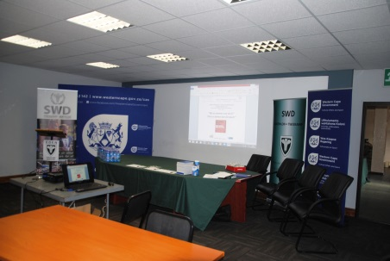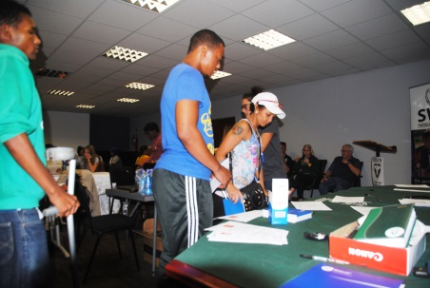



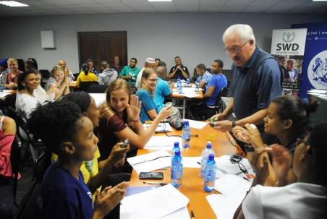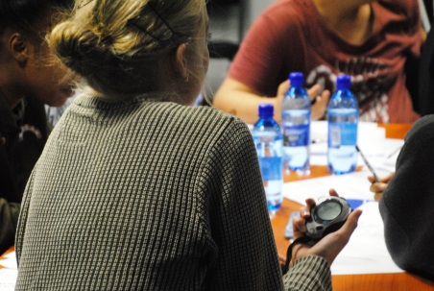

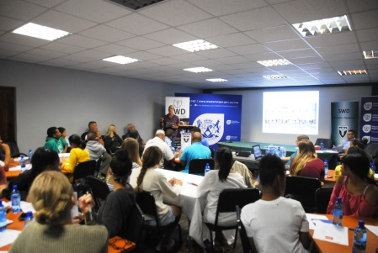

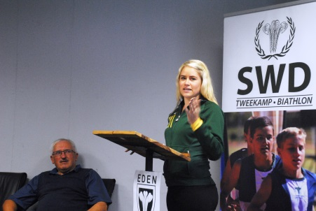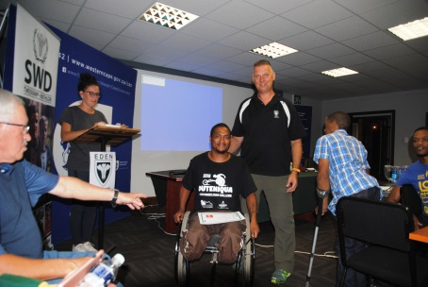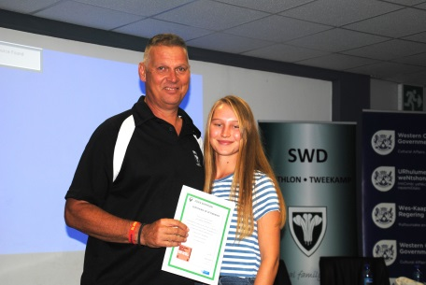

MEDIA

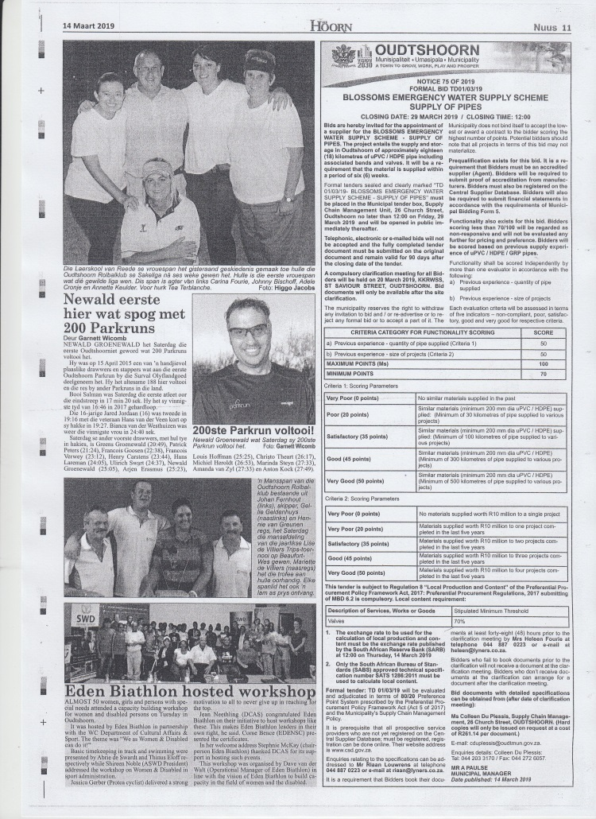

Eden Biathlon would like to thank DCAS as partner and all role players that made this event possible!

Many thanks

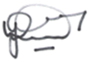
Dave van der Walt
Operasionele Bestuurder
Operational Manager
082-7734901
EDEN TWEEKAMP•BIATHLON


