12 February 2026

All Provincial Chairpersons / Alle Provinsiale Voorsitters

49 ^{ste} SA TWEEKAMPKAMPIOENSKAPPE – 20/21 MAART 2026, OUDTSHOORN

Die Bestuur van EDEN Tweekamp as deel van die WESKAAP TWEEKAMP FORUM nooi u provinsie graag uit om aan bogenoemde byeenkoms te kom deelneem. Dit word deur EDEN Tweekamp met die hulp van WP en BOLAND Tweekamp georganiseer en aangebied. This will be the 49th SA Biathlon Championship and Eden Biathlon and Oudtshoorn is ready to accommodate all provinces and their supporters. Neem asseblief kennis van die volgende:

FRIDAY 20 MARCH 2026
- Registration / team managers meeting – Eden Sport Academy – 12.00
  - Opposite De Jager Sport Complex in Voortrekker Street.
  - Ordered t-shirts will be available to collect.
  - R5 000 deposito by provinces must be paid into the Eden Biathlon account by 20 Feb 2026
  - Registration of teams will take place.

- Team Photos – De Jagers sport complex – 13.00 to 15.15
  - Van Zyl Naude - 083 309 8794 - official photographer.
  - Reservations must be directed to him personally.
  - Cost of team photos will be R100.
  - Action photos will also be available at the NA Smit Swimming pool

- Opening ceremony - De Jager Sports Complex - 16:00
  - 15.35 - Athletes to report at 120m mark
  - 15.40 - VIPs & provincial chairpersons take seats
  - 15.50 - March past & National Anthem
    - WP, Boland, Border, Central Gauteng, Eastern Province, Gauteng North, Griquas, KZN, Limpopo, Mpumalamga, Northern Free State, North West, Southern Free State, Eden
    - 16.00 - Opening ceremony

- President’s Function – Georgie Clubhouse – Oudtshoorn High – Directly after opening
  - Opposite the road of the opening event.
  - For SA Biathlon Executives, invited quests, chairpersons and team managers of provinces and sponsors.

SATURDAY 21 MARCH 2026
- Running – De Jager Sport Complex – 07.00
  - First heat Master 50+ at 07.00 see sequance below
    - Master 50+, Master 40+, u.9 – ready to report at 06.30 when called
    - Seniors, u.11, juniors – ready to report from 06.45 when called
    - Special needs, Master 70+, Master 60+ - ready to report from 07.15 when called.
    - Thereafter age groups need to be ready as per programme/sequance of events when called.
  - Team managers to make sure all athletes report when called
  - No athlete will be allowed to participate if not reporting at competitive steward
  - No non-official allowed in the call centre area

- Swimming – NA Smit pool – 10.00
  - The swimming event will be in 2 sessions – 10.00 to 13.00 and 13.30 to 16.30. The warm up for the first session will be from 09.00 to 09.45 (Master 50+, Master 40+, u.9, Seniors, u.11, Juniors, Special needs, Master 70+, Master 60+) and for the 2nd session from 13.00 to 13.30 (u.13, u.15, u.17, u.19). Above times are subject to change – important to listen to the announcer.
  - First session:
    - Master 50+, Master 40+, u.9 – to be ready to report from 09.30 when called.
    - Seniors, u.11, juniors – to be ready to report at 10.15 when called.
    - Special needs, Master 70+, Master 60+ - to be ready to report from 10.30 when called.
  - Second session:
    - u.13 girls and boys – to be ready to report from 13.10 when called
    - u.15 girls and boys – to be ready to report from 13.30 when called
    - u.17 girls and boys – to be ready to report from 14.00 when called
    - u.19 girls and boys – to be ready to report from 14.30 when called
  - Please refrain from interfering with the logistical setup of the infrastructure – eg. chairs for officials!

- Gala evening / Medal parade – Highgate Ostrich Farm – 19.00
  - Open air event on Highgate Ostrich Farm.
  - Take seats at 18.45.
  - Attendance only by wristband. This is included in the entry fee of the athlete. Any other person who want to attend the prize giving function need to purchase this through their province. [R100]
  - After prize giving it is a bring & braai and dance
  - Visitors can arrange own braaivleis or buy braaipacks – see below – for R65
  - Braaipack numbers per province on order form - attached
  - Bar fasicilities available.
  - HIGHGATE will provide braaiplekke, grids, fires as well as side dishes [salads, roosterbrode] and cutlery – R100 /person – to be inculded in summary sheet.
  - Highgate will lite fires at 19.00 and after prize giving visitors can braai when they want.
  - Guest are requested to bring head lamps, camping chairs as well as own braai grids if possible.
  - The LOC hope that all teams will support the gala evening.

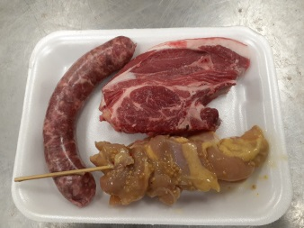
BRAAI Pack - content

Other
- Age groups
  - 6 athletes per age group plus 10 additional athletes from u.9 to u.19 – minimum 1 900 points
  - From Juniors to Master 70+ all above 1 750 points.
  - Max of 10 special needs athletes per province.

- School competition: This forms part of the normal entries. Just make sure that especially the under 15 athletes are in the right school on the computer system when they move from Primary to High School.

- Entries of athletes / teams
  - Fees:
    - R500 - SA Biathlon levy, venues entry and Highgate side dishes of athletes attending the function – it is important to indicate if athletes are going to attend the prize giving and gala evening – we don’t want to waste any food – on provincial order form
  - Entries
    - Sunday 8 March 2026 at 18h00. After that no more entries or changes – the program will be closed till Sunday morning after the SA‘s.
    - Athletes must have completed 2 meetings - provincial league/provincial championship/interprovincial
    - Please mail provincial order form to Dave van der Walt and Ernst van Schalkwyk
davesusvdw@gmail.com
edvs99@gmail.com
    - With entry the athlete give permission that their information and photos be used in the context of Biathlon – according to the POPIA act.

- Officials
  - For the first session at the pool (10.00 – 13.00), 2 x timekeepers per provinces are needed. Parents of u.9 and u.11 age groups should be able to assist.

- Parking
  - Track
    - Parking for officials, sponsors, vendors and VIP’s will be inside the track venue area. Public parking will be in St John Street [street parallel to Voortrekker Road to the north of the track. Please follow sign boards. Parking R30 per day or R50 is ticket is bought for both days. A pin location will be supplied to the team managers to distribute amongst their team parents.
- Pool
  - Limited parking space around pool. Please do not obstruct the entry road to the vehicle gate – it is reserved for emergency vehicles and suppliers.

- ORDERS – SA GOLF SHIRTS [see attached form]
R320 per golf shirt. Must be ordered separetely from team summary form. All orders must be submitted to Magdel Kotzé. [see form]

SPECIAL PROMOTIONS
- Sante Fe Spur offers 10% to Eden Biathlon for all biathletes and families dinning there. Just put your cash slip in the designated box provided.

ACCOMMODATION OPTIONS
Oudtshoorn & De Rust Tourism - Accommodation
https://www.oudtshoorn.com/accommodation/ Tel: 044 279 2532

OUDTSHOORN INN [room only per day]
ROOM RATE
1xsingle R750
1xdouble R850
1xtripple R1050
1xquad R1290
reservations1@oudtshoornhotel.com 044 279 1300

SCHOOL HOSTELS
PINEHURST HOSTEL [Ida Schmidt]
044 279 1623 pinehurstk@gmail.com

OUDTSHOORN VAARDIGHEIDSKOOL
044 272 6054 oudvskool@gmail.com

HIGHGATE
Mooiplaas Country Guesthouse & Spa
Tel. 044 279 4019 / Mobile: 082 504 7156
info@mooiplaasguesthouse.co.za / www.mooiplaasguesthouse.co.za

Bakenskraal Ostrich Palace
Tel. 073 614 5405
reservations@bakenskraal.com / www.bakenskraal.com

De Denne Country Guesthouse
Tel. 072 703 0488
info@dedenne.com / www.dedenne.com
Use this code when enquiring at Highgate : HG/EB 2026

- POPIA Act: By entering for this event the athletes consent to the use of their names and photos for biathlon purposes.
- Highgate Ostrich Farm offer a special price of R40 for a guided tour for biathletes and family

- Vendors
  - WIMPY/MUG & BEAN/Camp Roadhouse will be open for business at track and pool.

- Promotional material
  - Provinces are requested to bring any branding material along to be used at the track and pool.

- LOGISTICS: Attached order form and events program

- METHOD OF PAYMENTS: Your SimCash or any other preferred debit card or cash can be used.

- Trophies
  - All trophies to be handed in at team managers meeting to Gerhard Louwrens

SEQUENCE FOR RUNNING & SWIMMIMG
 | Running |  | Swimming
1 | Master 50+ ladies | 800m | Master 50+ ladies | 100m
2 | Master 50+ men | 800m | Master 50+ men | 100m
3 | Master 40+ ladies | 800m | Master 40+ ladies | 100m
4 | Master 40+ men | 800m | Master 40+ men | 100m
5 | u.9 girls | 400m | u.9 girls | 50m
6 | u.9 boys | 400m | u.9 boys | 50m
7 | Senior ladies | 800m | Senior ladies | 100m
8 | Senior men | 800m | Senior men | 100m
9 | u.11 girls | 400m | u.11 girls | 50m
10 | u.11 boys | 400m | u.11 boys | 50m
11 | Junior ladies | 800m | Junior ladies | 100m
12 | Junior men | 800m | Junior men | 100m
13 | Special needs | 400m | Special needs | 50m
14 | Master 70+ ladies | 400m | Master 70+ ladies | 50m
15 | Master 70+ men | 400m | Master 70+ men | 50m
16 | Master 60+ ladies | 400m | Master 60+ ladies | 50m
17 | Master 60+ men | 400m | Master 60+ men | 50m
18 | u.13 girls | 800m | u.13 girls | 50m
19 | u.13 boys | 800m | u.13 boys | 50m
20 | u.15 girls | 800m | u.15 girls | 100m
21 | u.15 boys | 800m | u.15 boys | 100m
22 | u.17 girls | 800m | u.17 girls | 100m
23 | u.17 boys | 800m | u.17 boys | 100m
24 | u.19 girls | 800m | u.19 girls | 100m
25 | u.19 boys | 800m | u.19 boys | 100m

Baie dankie / Many thanks

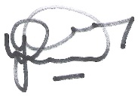
Dave van der Walt
Operasionele Bestuurder: Eden Tweekamp
Operational Manager: Eden Biathlon

SA Biathlon Championship Shirt

EDEN TEAM SHIRT AND SA GOLF SHIRT SIZE CHARD

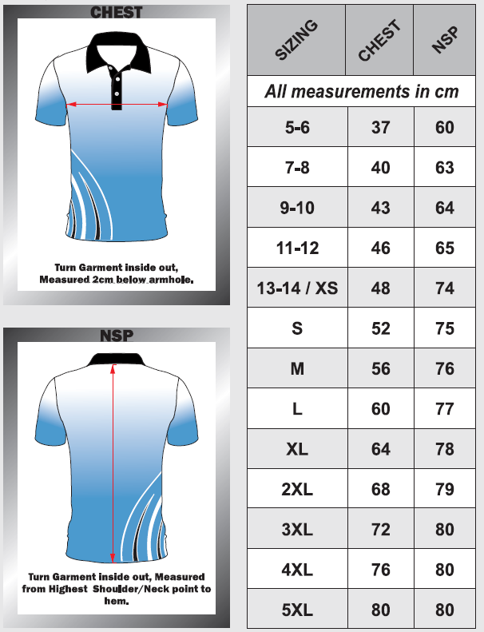

SA2026 Champs Golf Shirt

ORDER FORM – SA2026 GOLF SHIRT

THE ORDERS MUST BE PLACED ON THE ATTACHED PROVINCIAL SUMMARY SHEET

