OUDTSHOORN
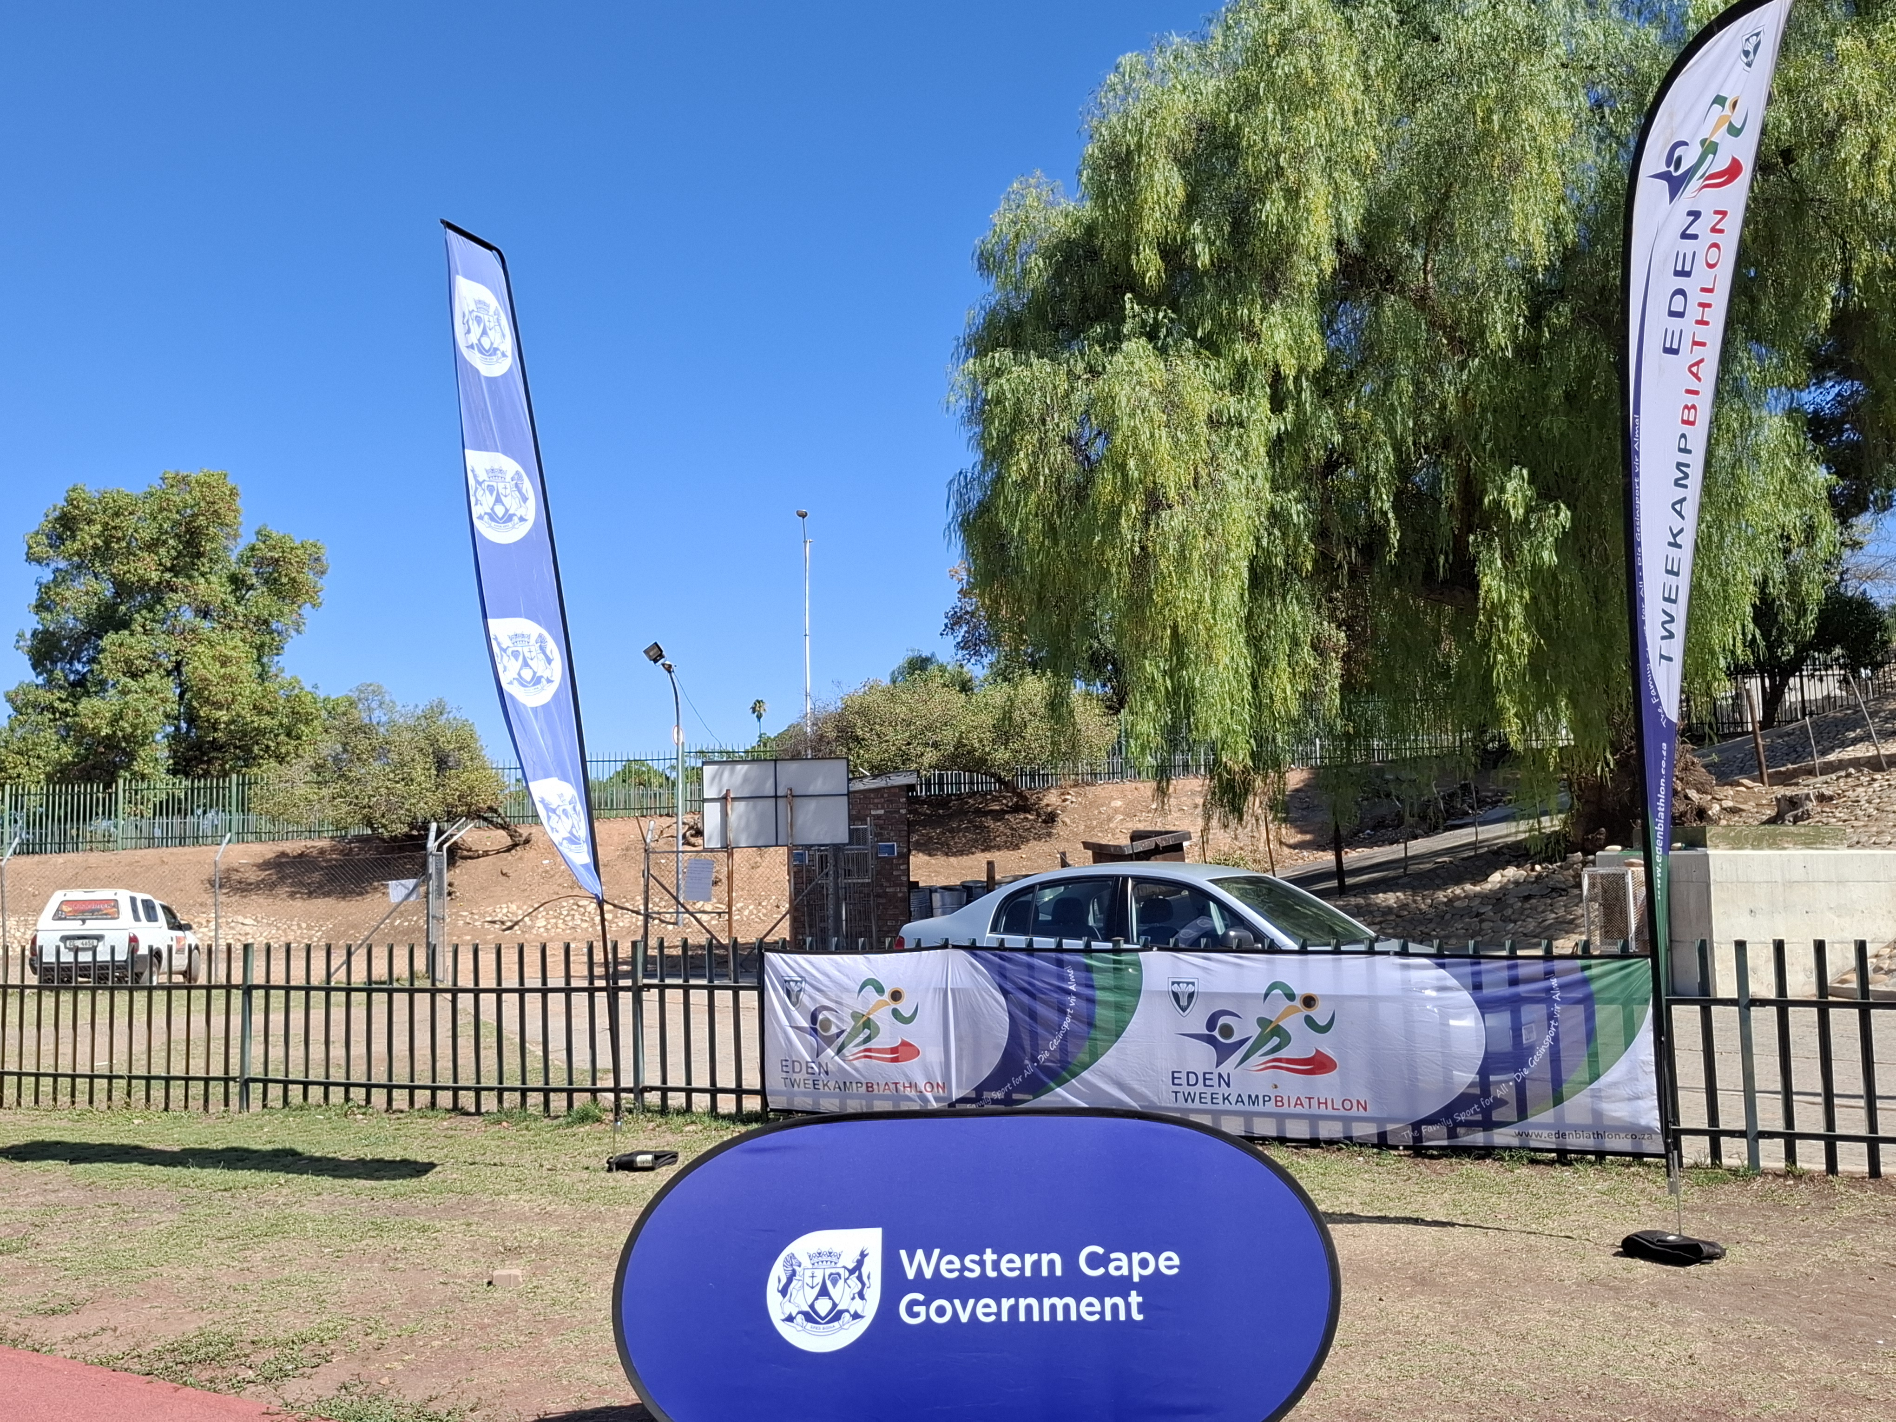

BRIDGTON DEVELOPMENT CLINIC  10 MARCH 2026 | REPORT

MEDIA

BRIDGTON DEVELOPMENT CLINIC ENDS EDEN BIATHLON SEASON.......
Eden Biathlon with the support of DCAS, hosted this final activity on 10 March in Oudtshoorn. 34 persons attended where John April [running] and Delia van Biljon [swimming] coached the athletes from Laurus PS and Eljada in 38°! Motivational prizes went to Cayrah Fielies [running] and Richi Jonkers [swim] both from Laurus PS. The development clinic was organised by Dave van der Walt, Eden Biathlon operational manager. Finally the athletes were treated on light refreshments.

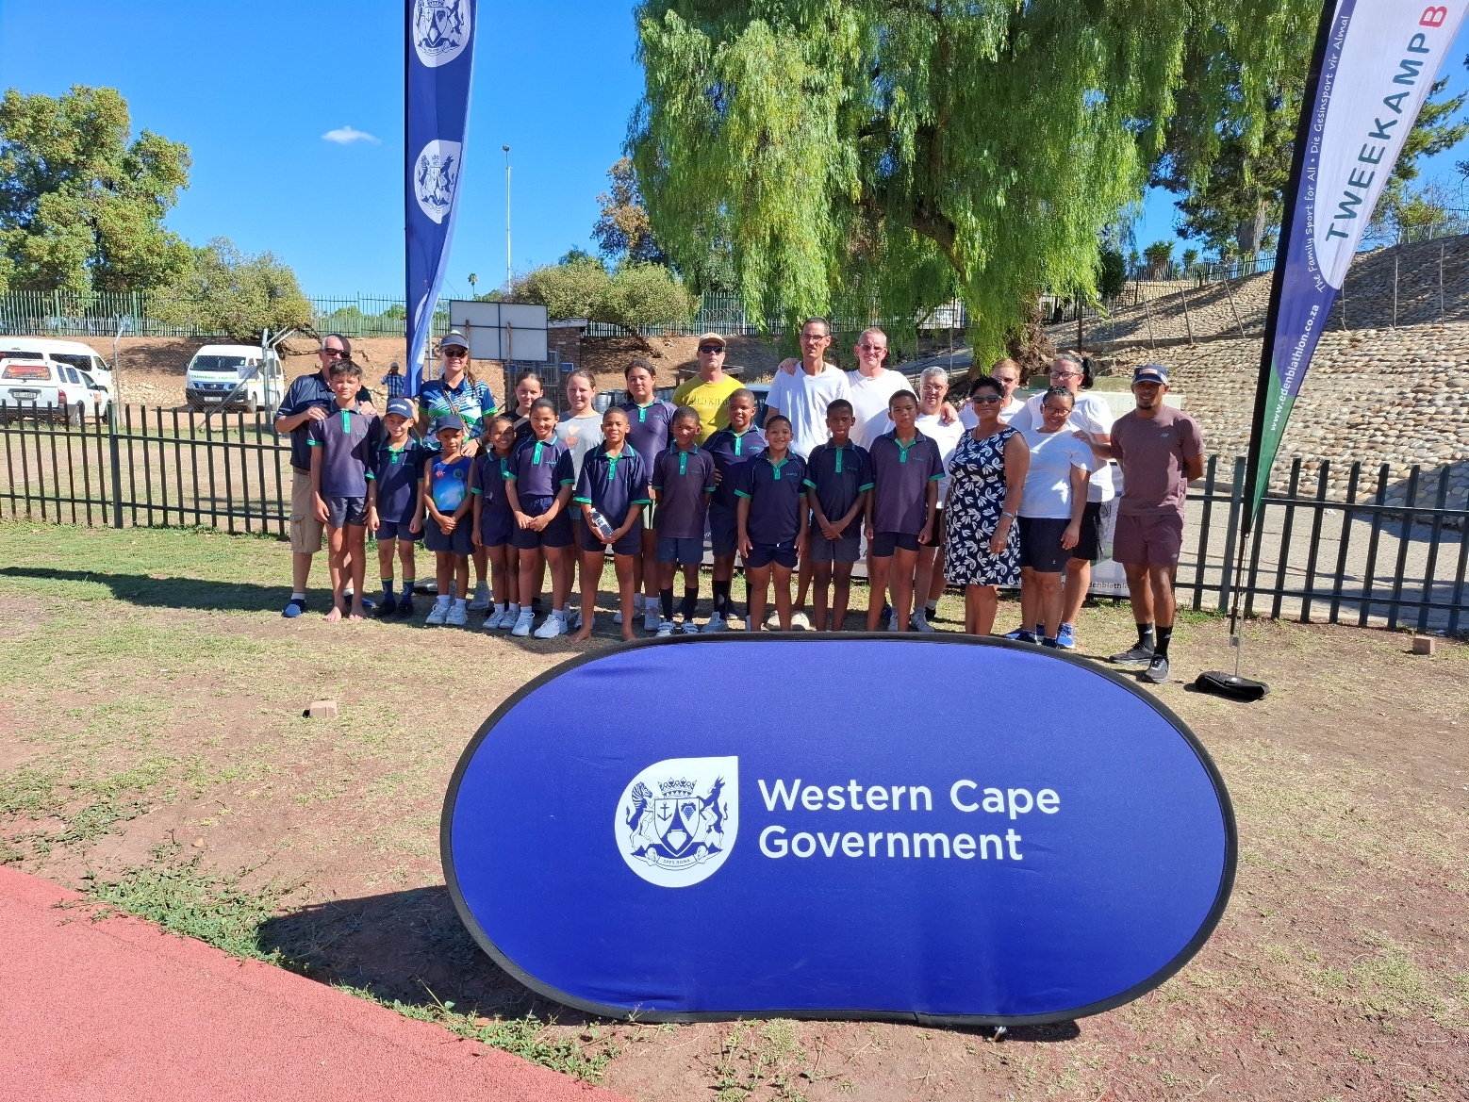

ATTENDANCE REGISTER

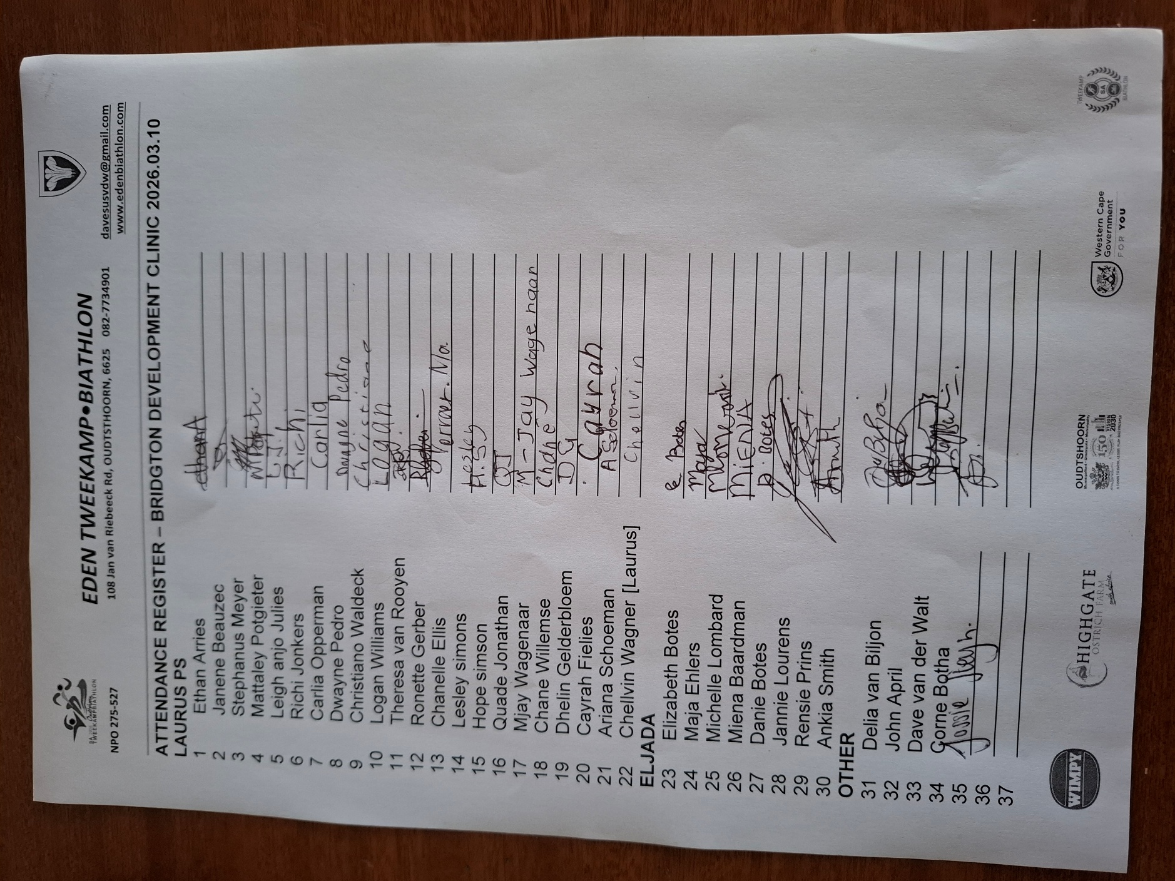

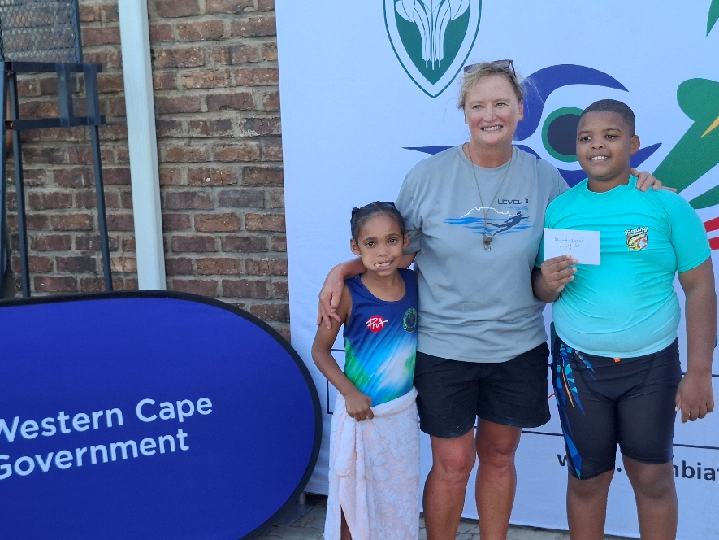
Die motiveringspryse vir belowende atlete saam met die swemafrigter – vlnr – Cyrah Fielies [hardloop], Delia van Biljon [swemafrigter], Richi Jonkers [swem].

PHOTO GALLERY
GALLERY


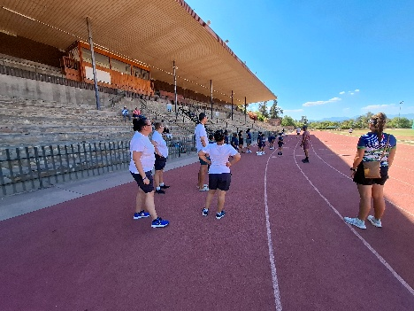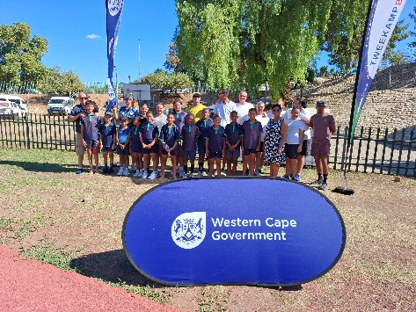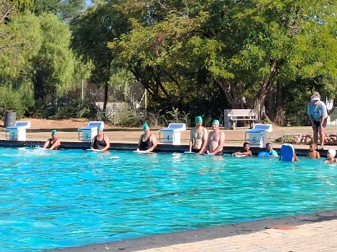

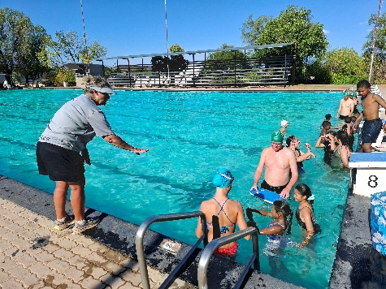

The EDEN Biathlon Federation would like to thank all the role players, specifically DCAS, for their support in the development of the sport code in the Eden sport district.

Many thanks


Dave van der Walt
Operasionele Bestuurder
Operational Manager

