2026.01.28
REPORT
EDEN WIMPY DOUBLES CAPACITY BUILDING PROJECT
27 JANUARY 2026

The EDEN WIMPY DOUBLES PROJECT is one of the annual capacity building components of EDEN Biathlon. It is organised by the Development Component of EDEN Biathlon in cooperation with DCAS and WIMPY [local sponsor]. This is normally the very first activity of the year. The main objective is to build out the capacity of the sport code and is aimed at the female, younger and older athletes.

The mechanics of the project is as follows: an established biathlete must bring a partner who has never partake in biathlon to do one of the components of biathlon [running or swimming]. There is no restriction on gender, age, race……. in many cases we get the situation that the athlete pair up with one of his/her parents or even grandparents! Each one compete in his/her age group and points are allocated on a point scale – the team with the most points is declared the winner! In many cases the new participant get hooked and we have won many such athletes for the sport!

STATISTICS
Date: 27 Jan 2026
Time: 17:00 – 19:00
Venue: De Jager sport Complex Athletics Track, Oudtshoorn
NA Smit Swimming Pool, Oudtshoorn
Teams: 24

MEDIA
WIMPY DOUBLES WENNERS........
24 Spanne het op Dinsdag 27 Jan aan die gewilde WIMPY DOUBLES byeenkoms op Oudtshoorn deelgeneem. Die konsep van die byeenkoms is dat elke span bestaan uit 'n aktiewe tweekamper wat een been [swem of hardloop] doen en die ander lid die ander een. Die ontwikkelings byeenkoms word ondersteun deur DCAS en geborg deur WIMPY. Die wenners was as volg:

• 1 Champions [Libby Swanepoel & Misha Meyer] 2145
• 2 Laps & Laces [Alrie Eloff & Lheanè du Plessis] 2125
• 3 Storm Dragons [Jean de Villiers & Daniel Martin] 2120
Beste Swempunt Lheanè du Plessis 1080
Beste Hardlooppunt Jean Botha 1110

PHOTO GALLERY

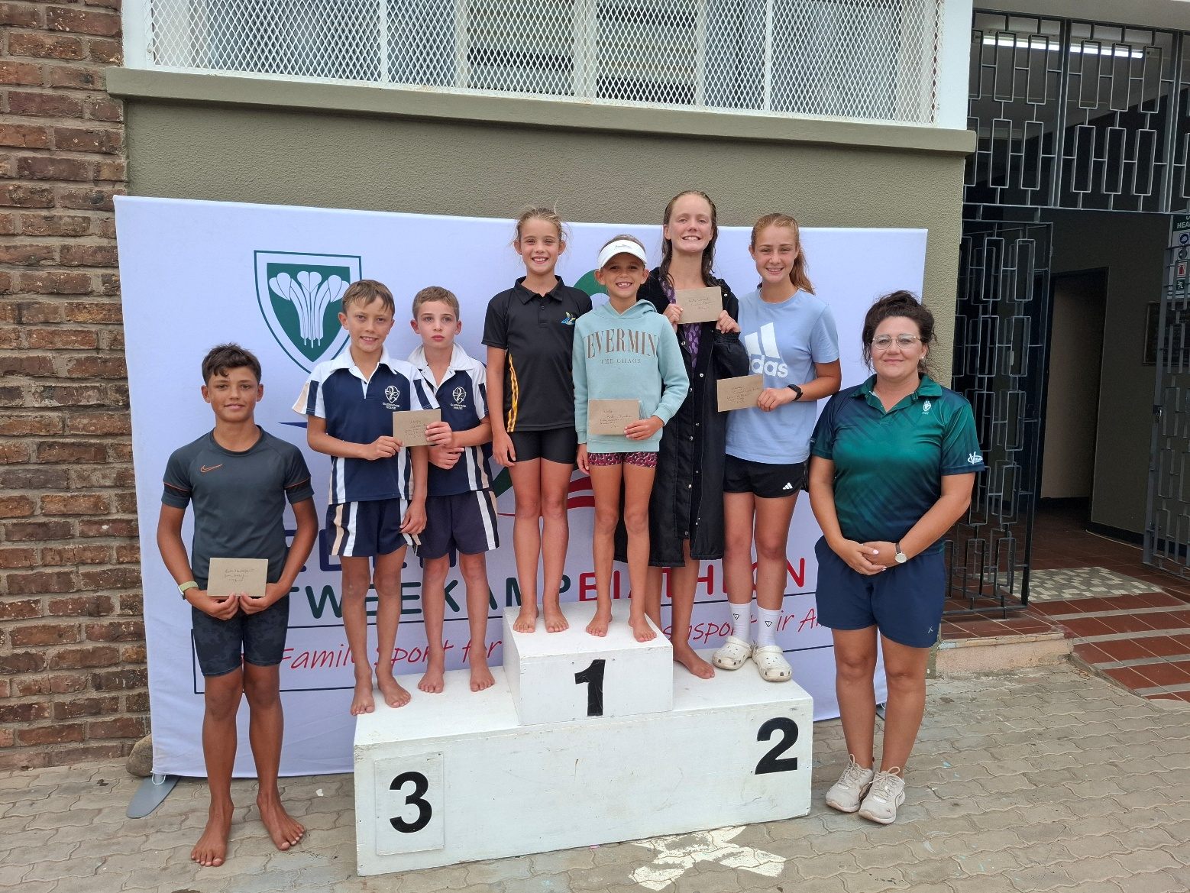

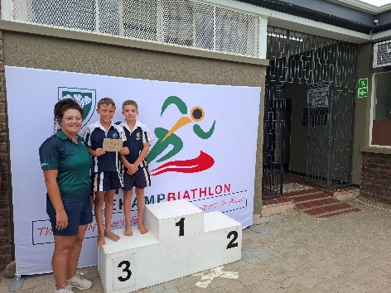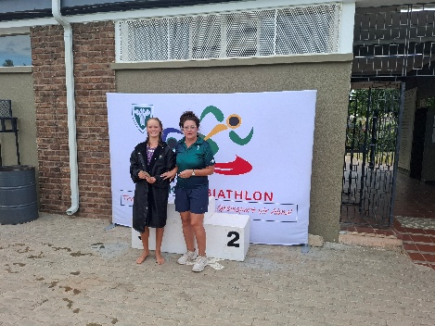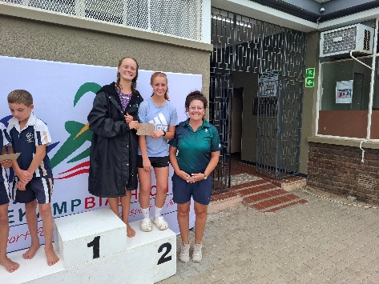

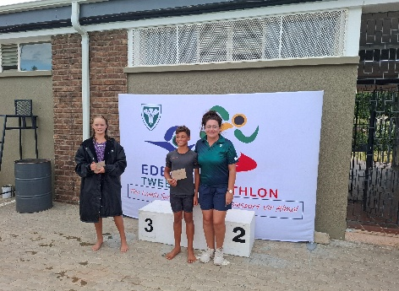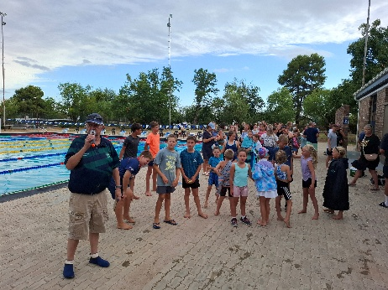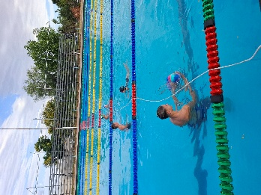
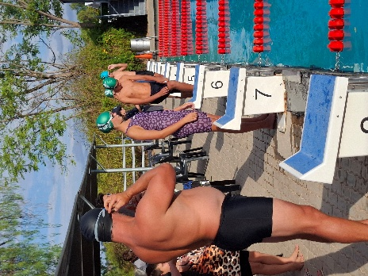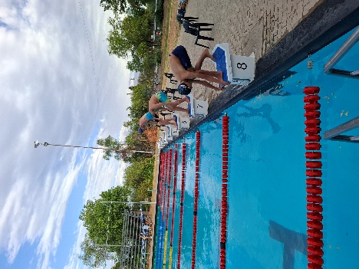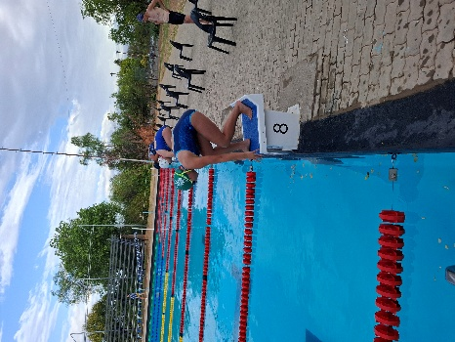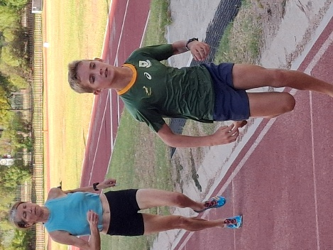

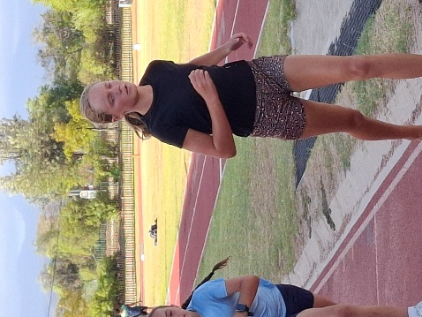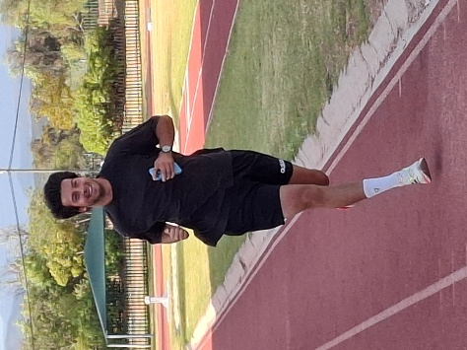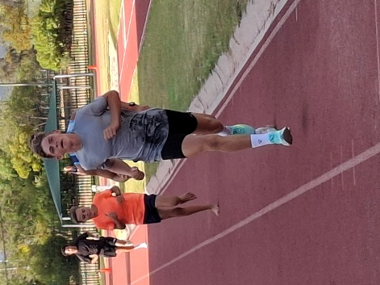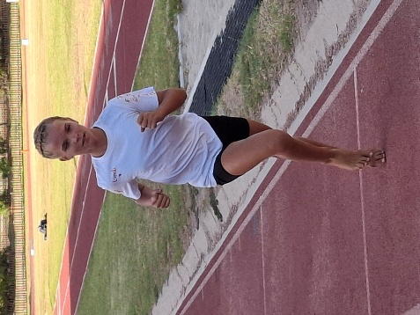

`

RESULTS [and attendance]

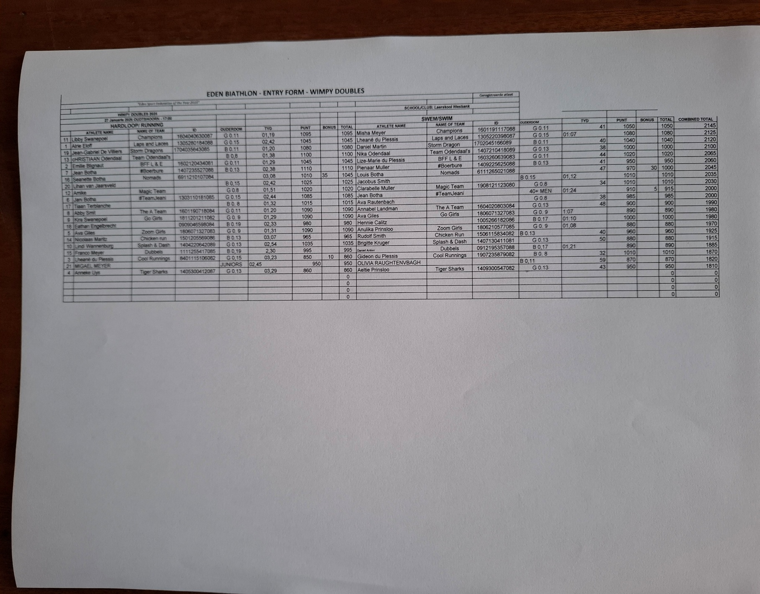

EDEN Biathlon would like to thank all role players that contribute to our Development programme, DCAS, the coaches, organisers and sponsors, for making the progress in biathlon possible.

Many thanks


Dave van der Walt
Operasionele Bestuurder
Operational Manager
082-7734901
EDEN TWEEKAMP•BIATHLON


